**Online Voting System Using Blockchain**

**(ovs)**

Project Submitted in Partial Fulfillment of the Requirements for the Degree of Bachelor of Technology in the field of Computer Science and Engineering

##### BY

**LOYAL DEBNATH (123200903067)**

**DONA SAHA (123200903055)**

**SAMIRAN BASU (123200903107)**

**SOUDEEP CHAKRABORTY (123200903120)**

**SWAPNIL PRANTO SARKAR (123200903143)**

Under the supervision

of

**JAYSHREE BHATTACHARYA**

(Assistant Professor)

**

##### Department of Computer Science and Engineering

JIS College of Engineering

Block-A, Phase-III, Kalyani, Nadia, Pin-741235

West Bengal, India

May, 2024



**CERTIFICATE**

This is to certify that **LOYAL DEBNATH (123200903067), DONA SAHA (123200903055), SAMIRAN BASU (123200903107), SOUDEEP CHAKRABORTY (123200903120), SWAPNIL PRANTO SARKAR (123200903143)** have completed their project entitled **ONLINE VOTING SYSTEM USING BLOCKCHAIN**, under the guidance of Assistant Professor **JAYSHREE BHATTACHARYA** in partial fulfillment of the requirements for the award of the **Bachelor of Technology in Computer Science and Engineering** from JIS college of Engineering (An Autonomous Institute) is an authentic record of their own work carried out during the academic year 2023-24 and to the best of our knowledge, this work has not been submitted elsewhere as part of the process of obtaining a degree, diploma, fellowship or any other similar title.

**--------------------------------- ------------------------------- ------------------------------**

**Signature of the Supervisor Signature of the HOD Signature of the Principal**

**Place:**

**Date:**



ACKNOWLEDGEMENT

The analysis of the project work wishes to express our gratitude to **Assistant Professor Jayshree Bhattacharya** for allowing the degree attitude and providing effective guidance in development of this project work. Her conscription of the topic and all the helpful hints, she provided, contributed greatly to successful development of this work, without being pedagogic and overbearing influence.

We also express our sincere gratitude to **Dr. BIKRAMJIT SARKAR**, Head of the Department of Computer Science and Engineering of JIS College of Engineering and all the respected faculty members of Department of CSE for giving the scope of successfully carrying out the project work.

Finally, we take this opportunity to thank to Prof. **(Dr.) Partha Sarkar**, Principal of JIS College of Engineering for giving us the scope of carrying out the project work.

Date:

**…………………………………….………………………………….**

LOYAL DEBNATH

B.TECH in Computer Science and Engineering

4thYEAR/8th SEMESTER

Univ Roll -- 123200903067

**…………………………………….………………………………….**

DONA SAHA

B.TECH in Computer Science and Engineering

4thYEAR/8th SEMESTER

Univ Roll -- 123200903055

**…………………………………….………………………………….**

SAMIRAN BASU

B.TECH in Computer Science and Engineering

4thYEAR/8th SEMESTER

Univ Roll -- 123200903107

**…………………………………….………………………………….**

SOUDEEP CHAKRABORTY

B.TECH in Computer Science and Engineering

4thYEAR/8th SEMESTER

Univ Roll -- 123200903120

**…………………………………….………………………………….**

SWAPNIL PRANTO SARKAR

B.TECH in Computer Science and Engineering

4thYEAR/8th SEMESTER

Univ Roll -- 123200903143

**List of Figures & Tables**

Fig 1.1: Blockchain Diagram Page 9 Fig:1.2: How does a transaction get into the blockchain Page 10

Fig:4.1: System Architecture Page 17

Fig:4.2: Conceptual Diagram Page 18

Fig:4.3: Sequence Diagram Page 19

**List of Tables**

1. SOFTWARE REQUIREMENTS Page 20

**CONTENTS**

**Title page 1**

**Certificate 2**

**Acknowledgement 3-4**

**List of Figures & Tables 5**

**Abstract 7**

**1. Introduction 8-10**

**2. Literature Survey 11**

**3. Methodology 12-13**

**4. Proposed Method 14-19**

**5. Result and Discussion 20-54**

**6. Conclusion 55**

**Reference 56**

**Abstract**

This venture report provides the development and implementation of an internet balloting device leveraging Blockchain generation. The machine ambitions to decorate the security, transparency, and performance of the balloting procedure through making use of Blockchain's immutable and decentralized nature.

For the frontend, HTML, CSS, and JavaScript have been employed to create an intuitive user interface. these technologies make sure a user-friendly vote casting experience available throughout numerous gadgets and systems.

in the improvement phase, the Ethereum-based totally Blockchain framework changed into utilized. specially, Truffle and Ganache were employed for clever contract development, deployment, and testing. Truffle provided a suite of development tools for Ethereum clever contracts, at the same time as Ganache served as a private blockchain for nearby development and testing purposes.

furthermore, Solidity, a settlement-orientated programming language, turned into applied to code the clever contracts governing the voting manner. Solidity's security features and compatibility with Ethereum made it an excellent desire for enforcing the backend logic of the web voting gadget.

via the combination of these technology, the online balloting machine guarantees transparency and immutability of the voting facts, mitigating dangers related to traditional centralized vote casting structures consisting of fraud and manipulation.

This task report information the design, implementation, and trying out of the web voting device, highlighting its capability to revolutionize the electoral method through leveraging the power of Blockchain technology.

**1.Introduction: -**

Voting whether conducted through the conventional ballot or through digital method paperwork the premise on which democracy depends digital vote casting has taken center location in studies with the goal of minimizing the fee related in putting in place the voting method, while ensuring the electoral integrity is maintained by gratifying privacy, safety and compliance necessities. The current method, whether electronic or now not has proved to be unsatisfactory with respect to transparency. it may be very difficult for the citizens to be confident that the vote he/she has casted for the duration of the election reflects within the election end result. electronic vote casting using Direct Recording electronic do no longer generate receipt on successful casting of votes. No file of election besides vote rely is made public by the government, which means that the electorate aren't confident of any outside interference in case of presidency carrying out the process of vote recounting. Non-governmental entities can also intervene with elections, via physical force, verbal intimidation, or fraud, that may bring about flawed casting or counting of votes. tracking for and minimizing electoral fraud is also an ongoing mission in nations with robust traditions of unfastened and truthful elections. changing the traditional technique with electronic approach the use of Blockchain technique can save you potential frauds that could take location for the duration of election.

**Blockchain technology** is a distributed network of interconnected nodes. a duplicate of distributed ledger is assigned to each node, every of which contains a entire history of all the transactions which have been processed through the community. every transaction processed generated a hash. The hash created depends now not most effective at the present day transaction however also on the hash of the preceding transaction. accordingly, any small exchange at the facts will effect the hash of the transaction. The transaction is written to the block. This permits the customers to stay self sustaining whilst the usage of the machine. A primary evaluation of Blockchain shows that it presents the potential of making the voting system greater comfortable and reliable.

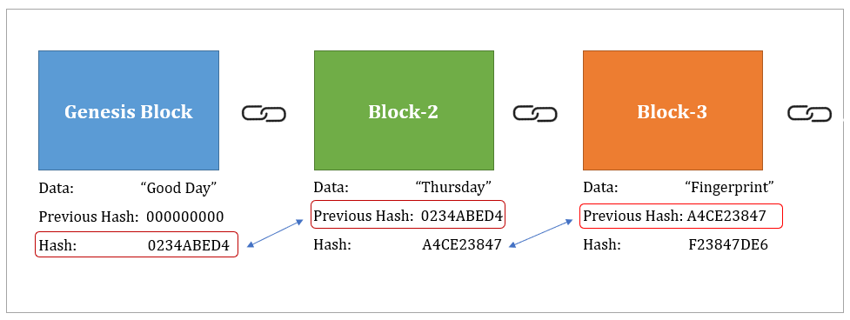

Fig:1.1: Block Chain Diagram

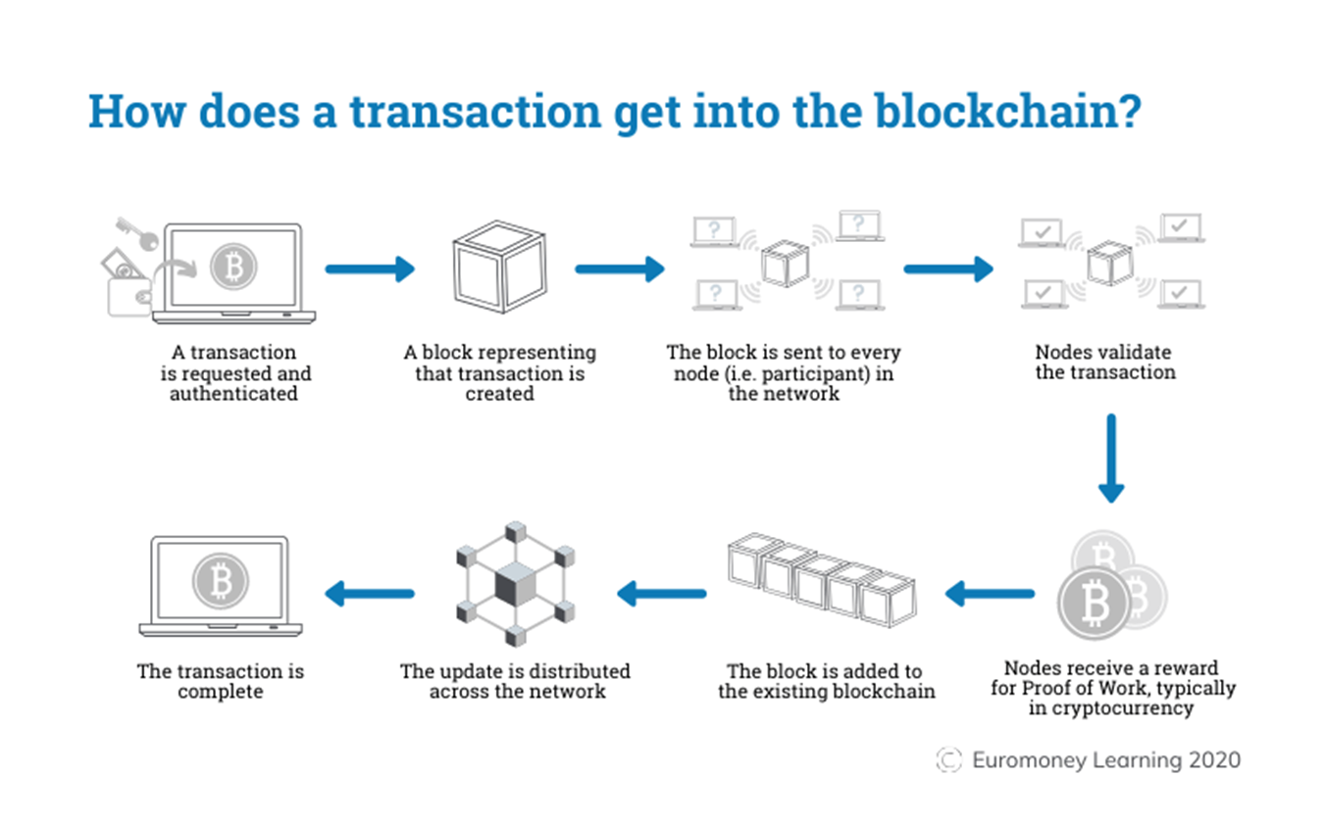

Fig:1.2: How does a transaction get into the blockchain

**2.Literature Survey:**

1. **Online Voting System for India Based on AADHAR ID - Himanshu Agarwal, G. N. Pandey in the year 2013.** A high security password is checked in the main database before voting is allowed. The voter will be able to confirm if the vote is transferred to the correct candidate or party. The tallying of the votes can be done manually, thus saving the data.
2. **Biometric voting system using Aadhaar card in India – S Chakraborty, S Mukherjee in the year 2016.** The main goal of this venture is to build a safe electronic voting machine using Finger printing technique that distinguishes evidence, so that we can use the Aadhar card database for specific marks. The online-voting confirmation process should be possible during the race voting season using finger vein detection, which enables the electronic poll reset to allow voters to cast their votes.
3. **Trustworthy Electronic Voting Using Adjusted Blockchain Technology - Basit Shahzad Raju, Jon Crowcroft in the year 2019**. This paper suggests a system that makes use of appropriate hashing methods to ensure data security. This paper introduces the concept of block-creation and block sealing. The implementation of a block sealing principle helps to make the blockchain flexible to meet polling process requirements.
4. **Security Analysis of India’s Voting Machine - Hari K. Prasad, Arun Kankipati, Sai Krishna Sakhamuri in the year 2010** . Security Analysis was performed on real Indian EVM system. This paper states that EVM can be tampered in many ways such as, tampering with software before CPU manufacture, tampering with machine state, substituting a look a-like CPU and/or a unit and thus secrecy of the ballot can be violated. The proposed voting system does not have any major hardware requirements, thus elimination all the above disadvantages of EVM. Also the proposed model uses blockchain which ensures that the vote transfer to candidate’s ballot is easy and secure.

**3.Methodology:**

**3.1. Introduction:**

* Provide an overview of the project, including its objectives, significance, and the technologies employed.
  1. **System Architecture:**
* Illustrate the architecture of the Online Voting System using Blockchain, highlighting the integration of HTML, CSS, JavaScript for frontend development, and Truffle, Ganache, Solidity, Node.js, and Meta mask for backend and smart contract development.

**3.3. Requirements Analysis:**

* Conduct a comprehensive analysis of functional and non-functional requirements, including user requirements, security requirements, performance requirements, and regulatory compliance.

**3.4. Design Phase:**

* **Frontend Design:**

Describe the design process of the user interface using HTML, CSS, and JavaScript, focusing on user experience and accessibility.

* **Backend Design:**

Explain the design of smart contracts using Solidity, emphasizing security, reliability, and efficiency.

Discuss the integration of Truffle and Ganache for smart contract compilation, deployment, and testing.

Outline the design of backend server using Node.js for handling user requests and interacting with the blockchain network.

**3.5. Implementation:**

**3.5.1. Frontend Development:**

Detail the implementation of the user interface using HTML, CSS, and JavaScript, including layout design, form validation, and event handling.

**3.5.2. Backend Development:**

* + - Explain the development of smart contracts using Solidity, covering contract logic, data structures, and functions.
    - Describe the implementation of backend server using Node.js, including API endpoints, request handling, and blockchain interaction via web3.js.
    - Provide code snippets and screenshots to illustrate key implementation aspects.
  1. **Testing:**

**3.6.1. Unit Testing:**

* + - Discuss the unit testing of smart contracts using Truffle framework, ensuring contract functionalities work as expected.
    - Describe the unit testing of backend server endpoints using testing frameworks like Mocha or Jest.

**3.6.2. Integration Testing:**

* + - Explain the integration testing of frontend and backend components to ensure seamless interaction and functionality.
    - Perform end-to-end testing of the Online Voting System to validate its overall behavior and performance.
  1. **Deployment:**

Outline the deployment process of the Online Voting System, including deploying smart contracts to the blockchain network using Truffle and Ganache, and deploying backend server to a hosting environment.

* 1. **Security Considerations:**

Discuss the security measures implemented in the Online Voting System to mitigate common threats such as tampering, unauthorized access, and denial-of-service attacks.

Address the security implications of using blockchain technology for online voting, including consensus mechanisms, immutability, and privacy.

**3.9. Evaluation:**

Evaluate the Online Voting System against the defined requirements and objectives, highlighting its strengths, limitations, and areas for improvement.

Gather feedback from users and stakeholders to assess user satisfaction and identify potential enhancements.

**3.10. Conclusion:**

Summarize the key findings and contributions of the project, reiterating its significance in the context of online voting systems and blockchain technology.

**3.11. References:**

Cite relevant literature, documentation, and resources consulted during the project implementation and research process.

**3.12. Appendices:**

Include supplementary materials such as code snippets, configuration files, and additional documentation for reference.

**4. Proposed Method:**

1. **Introduction:**
   1. Provide an overview of the proposed project, emphasizing the need for secure and transparent online voting systems and the potential benefits of leveraging blockchain technology.
2. **Objective:**
   1. Define the primary objective of the project, which is to develop an Online Voting System that ensures integrity, security, and transparency in the voting process through the use of blockchain technology.
3. **System Architecture Overview:**
   1. Briefly describe the proposed system architecture, highlighting the integration of HTML, CSS, JavaScript for frontend development, and Truffle, Ganache, Solidity, Node.js, and Metamask for backend and smart contract development.
4. **Proposed Methodology:**
   1. **Requirements Gathering:**
   2. Conduct stakeholder interviews and analysis to gather requirements, including functional and non-functional requirements such as user authentication, ballot secrecy, scalability, and auditability.
   3. **System Design:**
   4. **Frontend Design:**
      1. Design the user interface using HTML, CSS, and JavaScript to create an intuitive and responsive voting platform accessible via web browsers.
   5. **Backend Design:**
      1. Design smart contracts using Solidity to define the voting mechanism, candidate registration, ballot casting, and result tallying.
      2. Develop backend server using Node.js to handle user authentication, request routing, and interaction with the blockchain network.
   6. **Development:**

* **Frontend Development:**
  + 1. Implement the user interface components using HTML for structure, CSS for styling, and JavaScript for dynamic behavior, ensuring compatibility across different devices and browsers.
* **Backend Development:**
  + 1. Develop smart contracts using Solidity, implementing the core functionalities of the voting system such as voter registration, ballot creation, and tallying.
    2. Integrate Truffle and Ganache for smart contract compilation, deployment, and testing.
    3. Implement backend server using Node.js, incorporating APIs for user authentication and interaction with the blockchain network via web3.js.
    4. Integrate Metamask for secure interaction with the Ethereum blockchain.
  1. **Testing:**
  2. Conduct thorough testing of both frontend and backend components, including unit testing, integration testing, and end-to-end testing to ensure functionality, security, and performance.
  3. **Deployment:**
  4. Deploy the Online Voting System to a hosting environment, including deploying smart contracts to the Ethereum blockchain network and deploying backend server to a web server or cloud platform.

1. **Expected Outcomes:**
   1. Describe the expected outcomes of the project, including a secure and transparent online voting platform that ensures the integrity of the voting process and enhances voter trust and participation.
2. **Timeline:**
   1. Provide a timeline outlining the proposed schedule for each phase of the project, including requirements gathering, design, development, testing, and deployment.
3. **Resource Requirements:**
   1. List the resources required for the successful implementation of the project, including software tools, development environments, and personnel.
4. **Risk Management:**
   1. Identify potential risks and challenges associated with the project, such as security vulnerabilities, regulatory compliance, and scalability issues, and propose mitigation strategies.
5. **Conclusion:**
   1. Summarize the proposed methodology, emphasizing its potential to address the challenges of traditional voting systems and enhance the integrity and transparency of the voting process through blockchain technology.
   2. **References:**
   3. Provide a list of references, including academic literature, technical documentation, and online resources consulted during the planning and design phase of the project.
   4. Top of Form

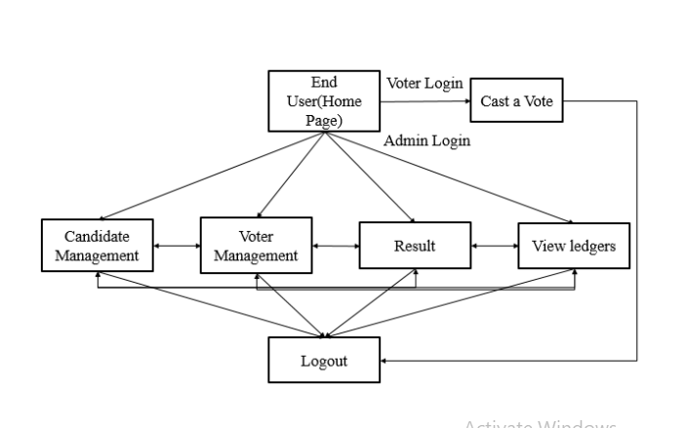Fig:4.1: SYSTEM ARCITECTURE

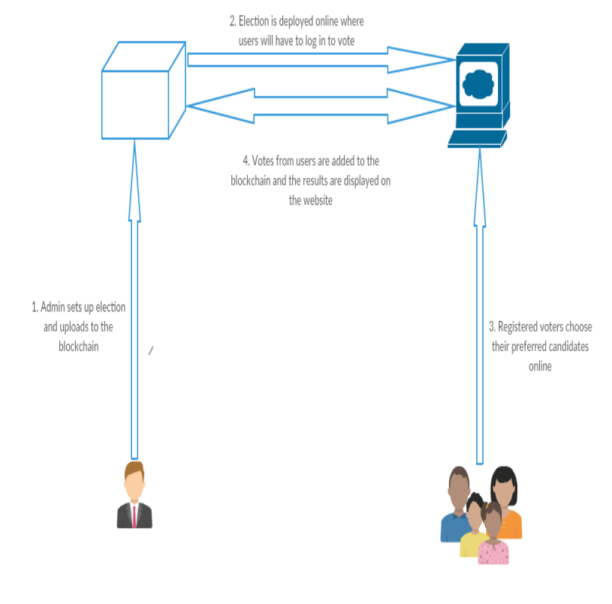

Fig:4.2: Conceptual Diagram

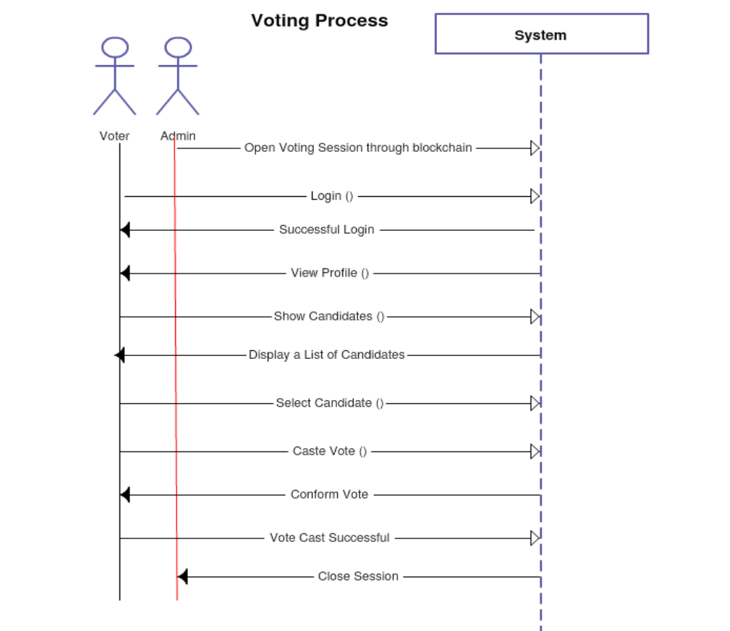

Fig:4.3: Sequence Diagram

SYSTEM REQUIREMENTS

1. SOFTWARE REQUIREMENTS

|  |  |  |
| --- | --- | --- |
| Software | Type | Version |
| Windows | Operating System | 7 or above |
| Visual Studio | Framework | 1.76 |
| Ganache | Ethereum Blockchain Server | 2.4.0 |
| MetaMask | Ethereum Wallet | 7.7.9 |
| Truffle | Development framework for ETH | 5.1.31 |
| Localhost | Server |  |

2. HARDWARE REQUIREMENTS

1. Processor: Intel Quad core 1.7 GHZ Processor or above.
2. HD: Minimum 10 GB of HD.
3. RAM: Minimum 4 GB of RAM

**6. Results and Discussion:**

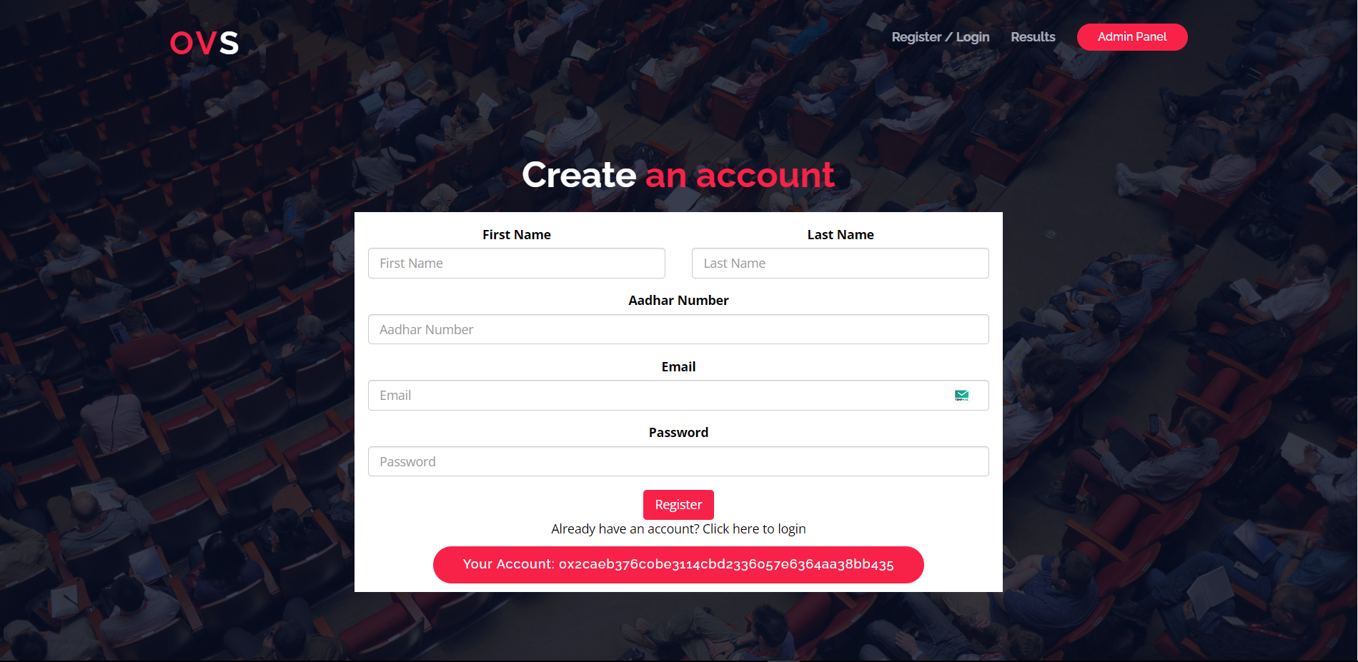

Figure 6.1. Registration Page

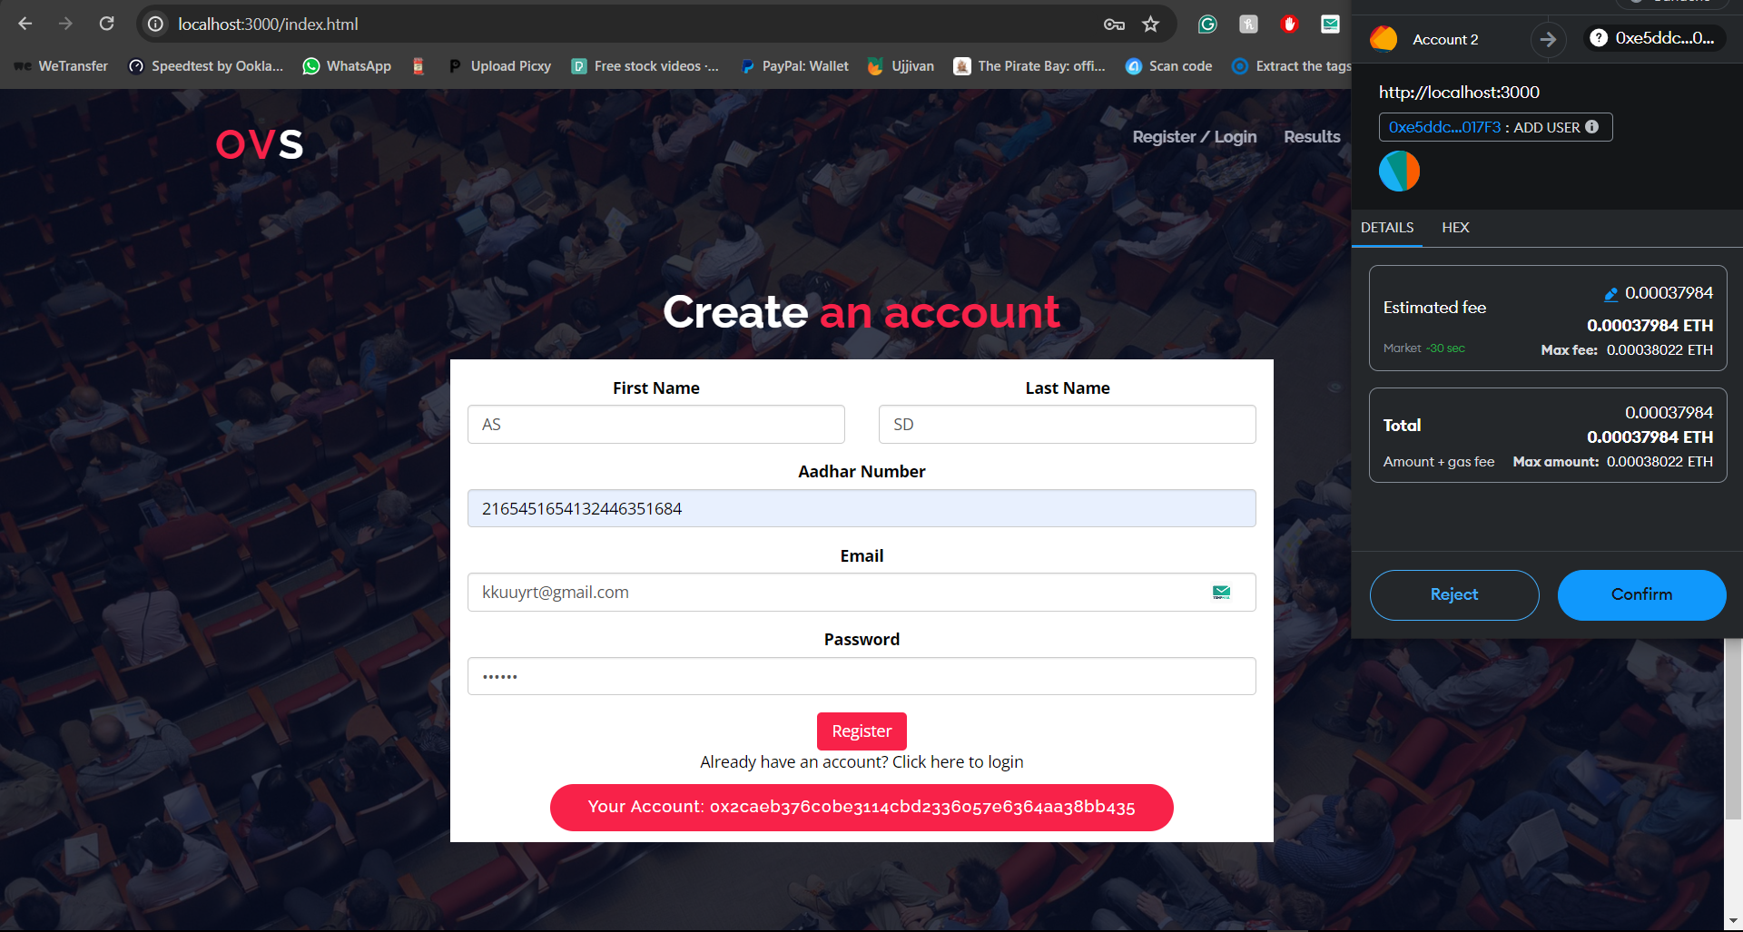

Figure 6.2. Registration Page

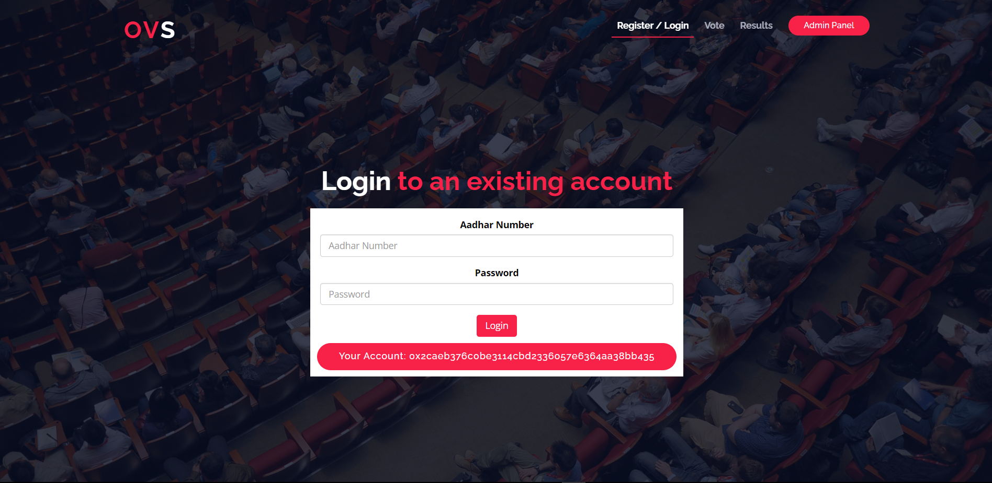

Figure 6.3. Login Page



Figure 6.4. Successful Login page

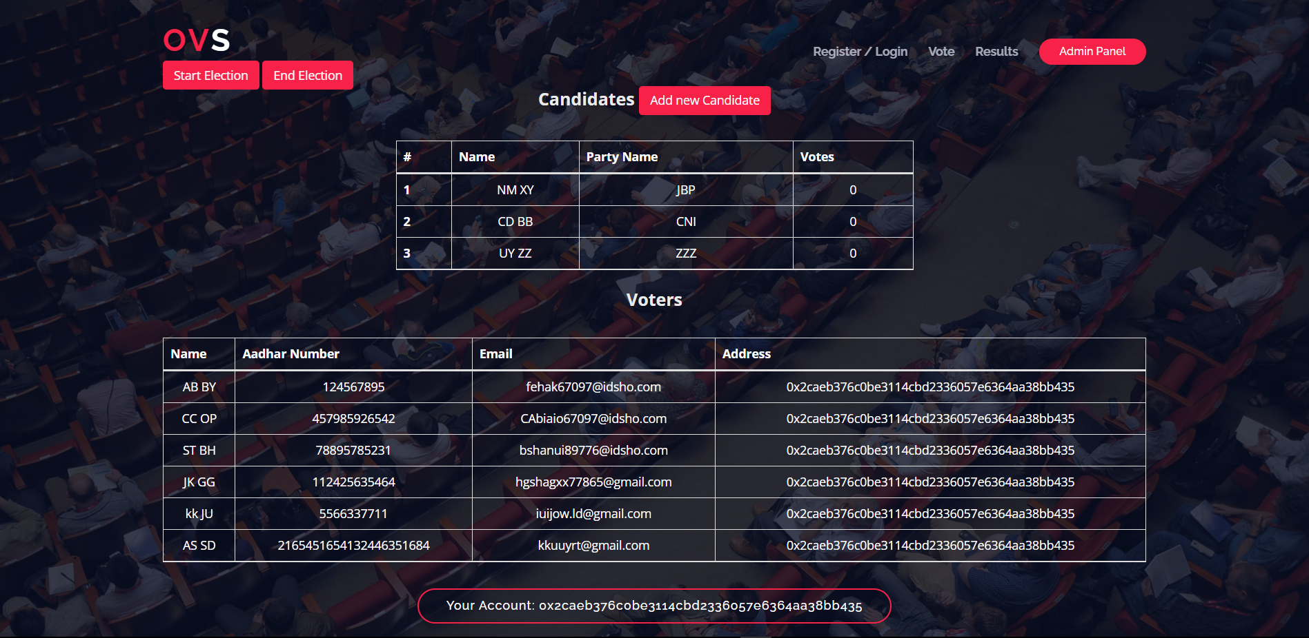

Figure 6.5. Admin Portal

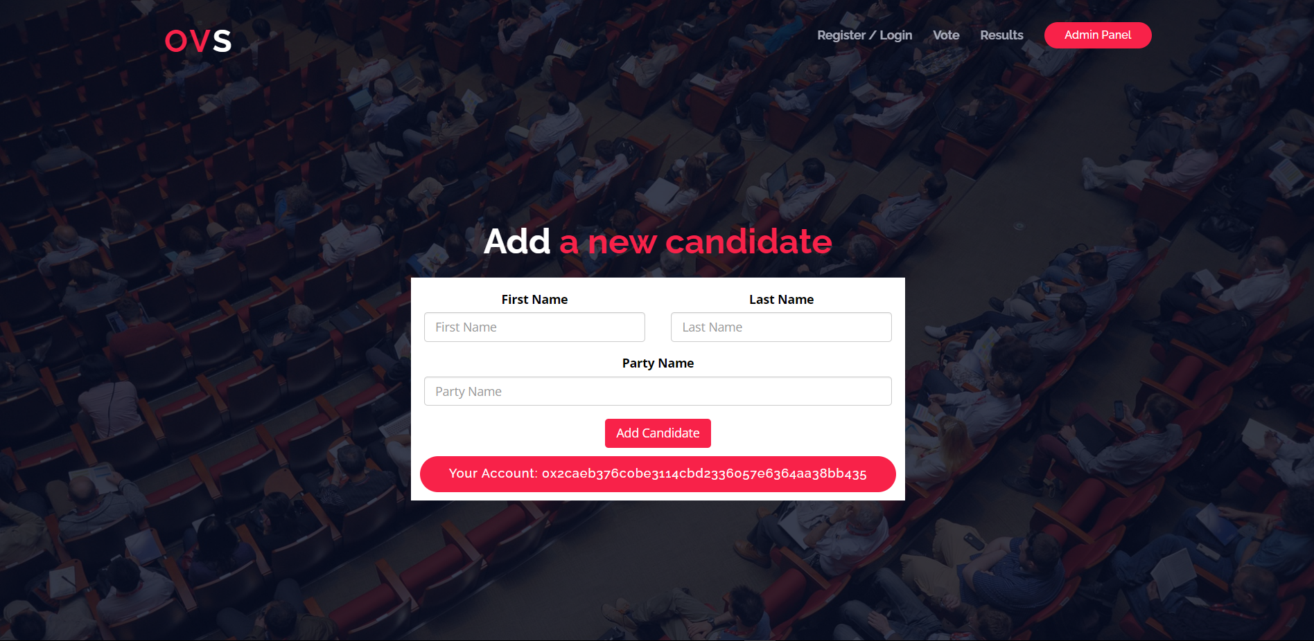

Figure 6.6. Candidate adding Portal for Admin

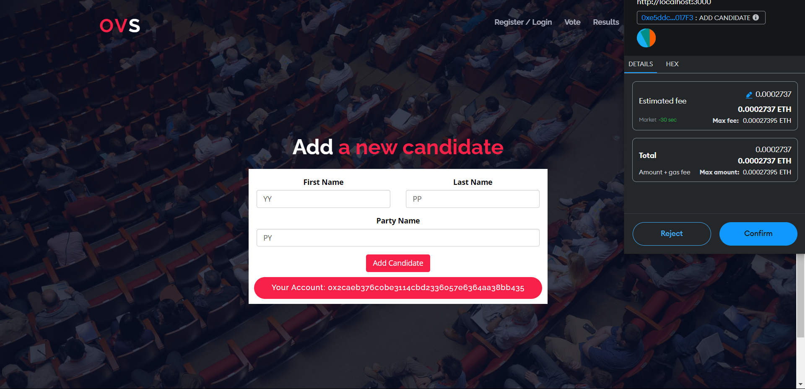

Figure 6.7. Adding Candidate

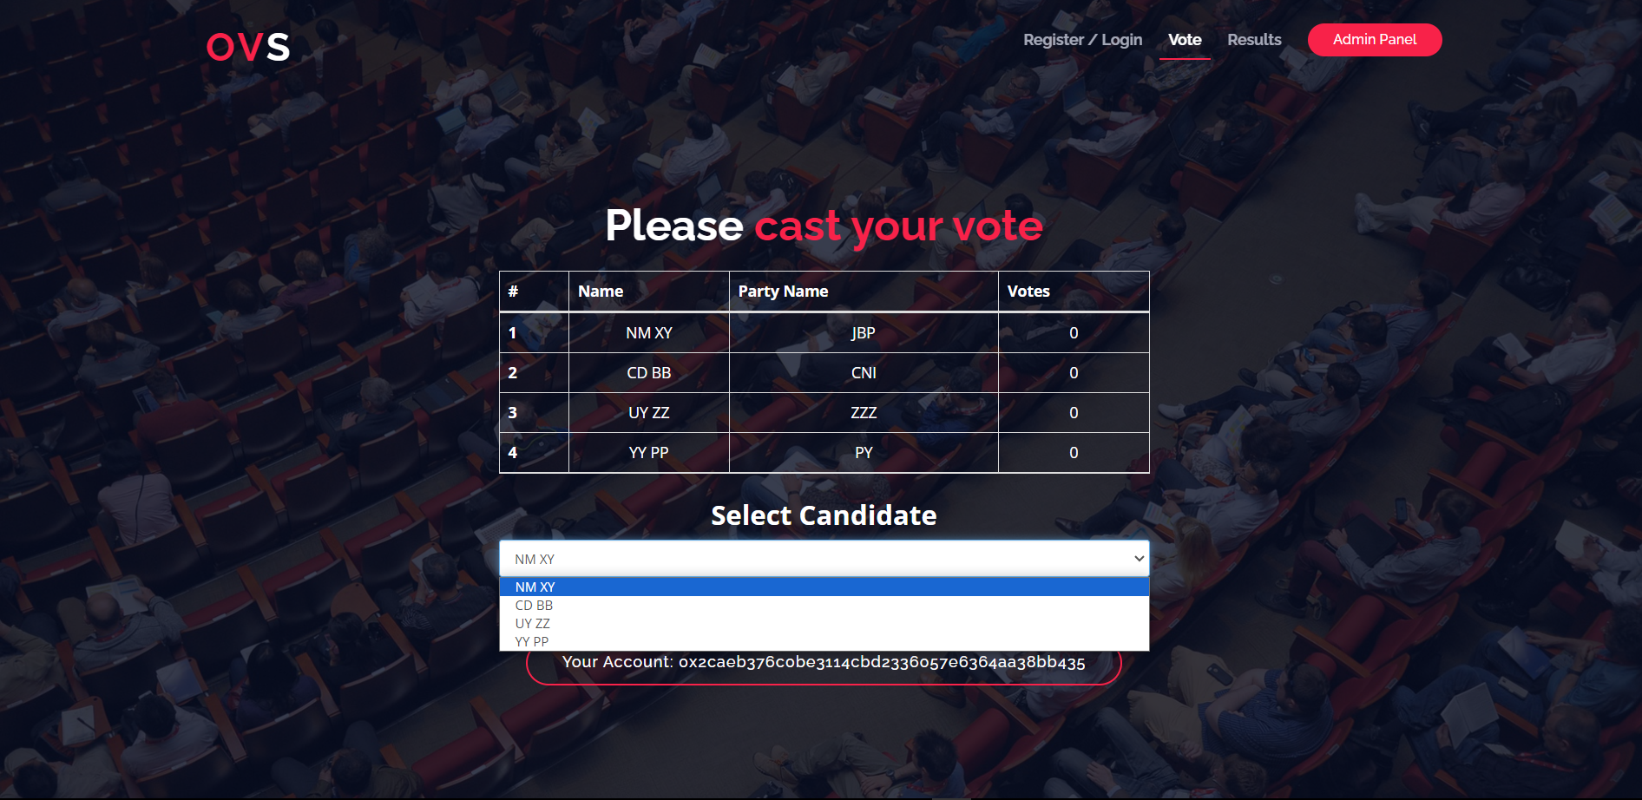

Figure 6.8 Voting page

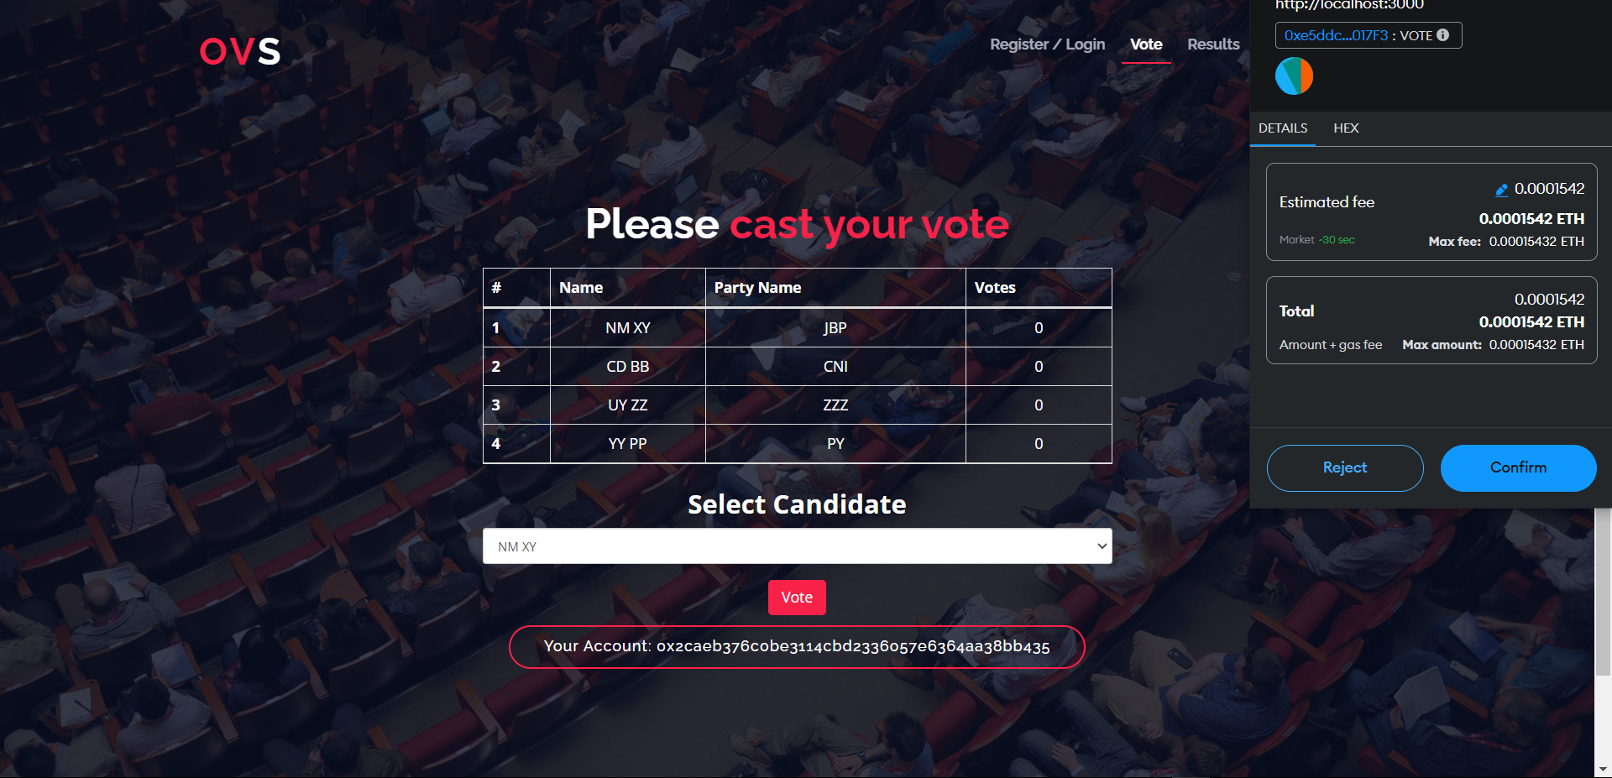

Figure 6.9. Casting Vote

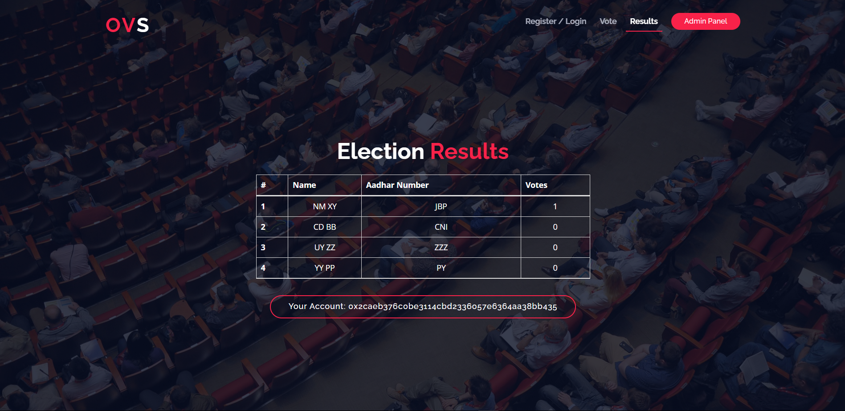

Figure 6.12. Result

**6.1. TESTING**

Testing refers to examining the software system to identify errors and ensure that the system meets the requirements specifications. The approach in this case includes the Module testing and Integration System Testing. The module testing involved examining the memory dump of the program and using web console of the development browser. This technique was used to test each independent unit for proper functioning.

* Integration

The individually tested modules were integrated and tested together and errors and bugs collected and corrected.

* System Testing

The entire system was tested and sample data was input to ensure the proper working of the system and that it meets the requirements of the system and that it is error free

* Software Testing

Test Case Matrix for the System

**6.2. Test Table:**

|  |  |  |  |
| --- | --- | --- | --- |
| Test Case | Expected Results | Actual Result | Pass/Fail |
| Login In (Positive Match) | Should positively identify a user and redirect to a dashboard with specific rights that are appended to the user. | Positively identifies a user and redirects to voting page with information about the user. The user also is granted specific rights depending on level of access. | Pass |
| Login In (Negative Match) | Should decline login request and display a reason why the requestwas declined. | Declines login request and displays the reason why the request was declined. | Pass |
| Add candidate | Should be able to add candidate into the voting process | Candidate details are displayed in the voting page where voters can choose. |  |
| Vote | Should able to cast a vote for the preferred candidate. | Voters select their preferred candidate and click on vote. That candidates vote count increases by 1 | A screenshot of a voting site  Description automatically generatedPass |
| Check results | Should accurately show the tally of all the votes casted. | Once someone casts their vote they are taken to the results page which shows a real time vote tally | Pass |
| Cannot vote twice | Should prevent users from casting a second vote once they have already voted. | The select candidate option and vote button disappears once a candidate has casted their vote. | Pass |

**6.3. FEATURES PROVIDED BY THE SOFTWARES:**

**6.3.1. GANACHE:**

Ganache is a development tool in the Truffle Suite and is used for setting up a personal Ethereum Blockchain to deploy contracts, develop your applications, and run tests. It

consists of details of the transaction such as hash value (Txn Hash), block number of the

transaction, and transaction fee (Txn Fee), from address and to address.

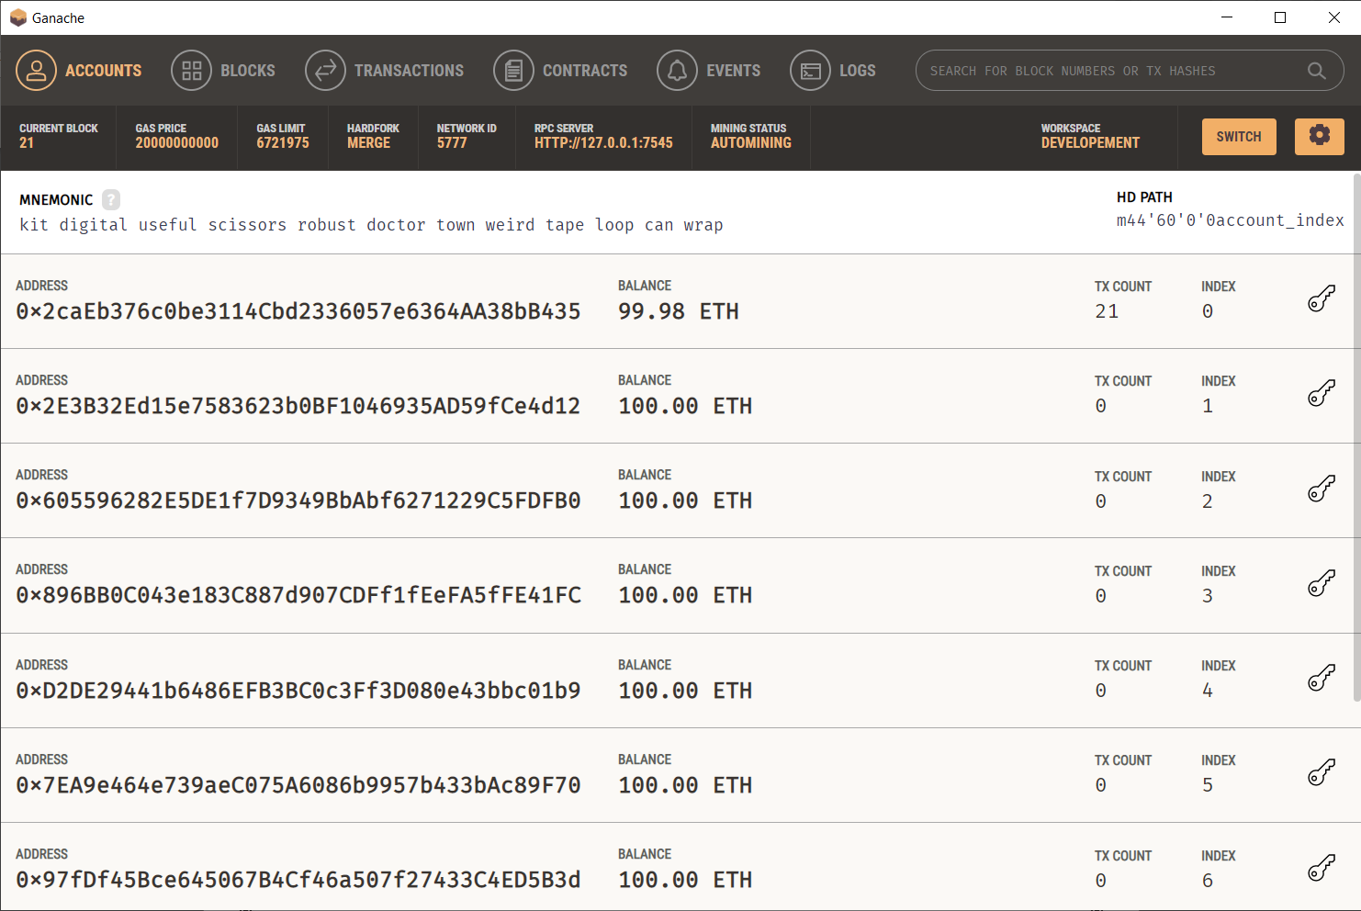

**Fig.6.13. Ganache**

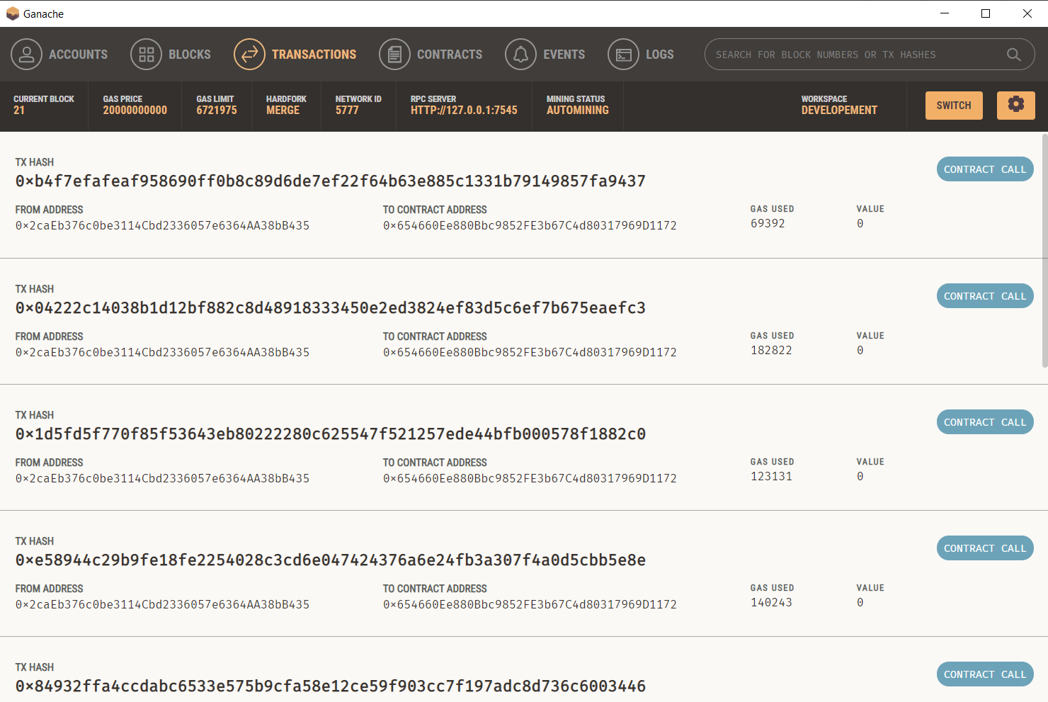

**Fig. 6.14. Ganache Transactions**

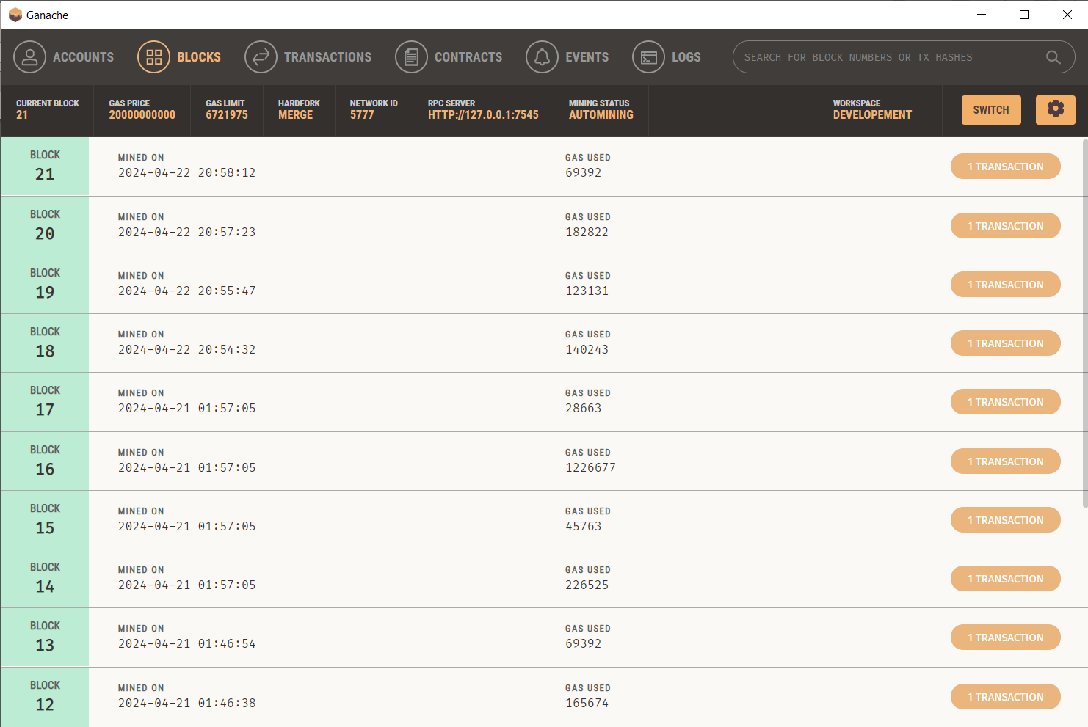

**Fig.6.15. Ganache Blocks**

**6.3.2. TRUFFLE**:

Truffle is a development environment utilizing the EVM (Ethereum Virtual Machine) as a basis. The environment specializes in smart contract development. This environment features several great functionalities that help App developers and is used to deploy/execute the smart contracts.

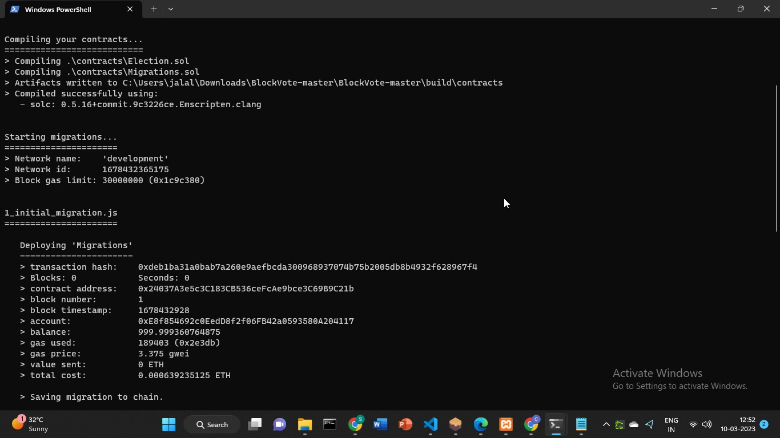

Fig 6.15. Truffle Migration

**6.3.3. METAMASK:**

MetaMask is a software cryptocurrency wallet used to interact with the Ethereum blockchain. It allows users to access their Ethereum wallet through a browser extension or mobile app, which can then be used to interact with decentralized applications.

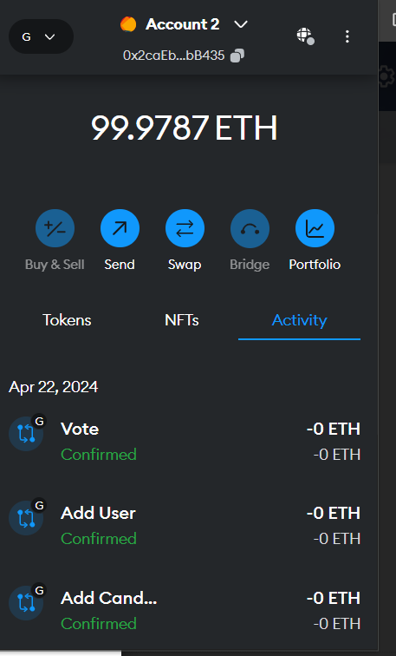

Fig 6.16. Metamask Wallet

**6.3.4. Code Implementation:**

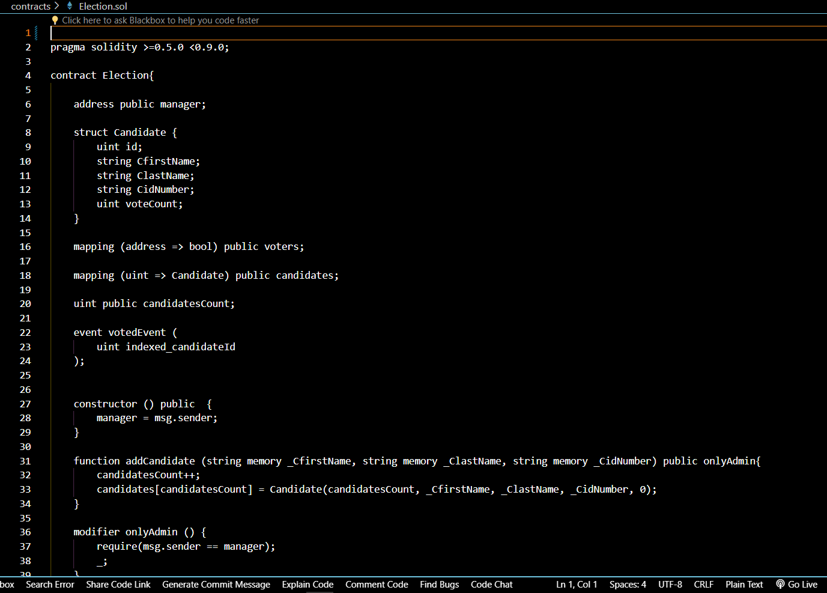

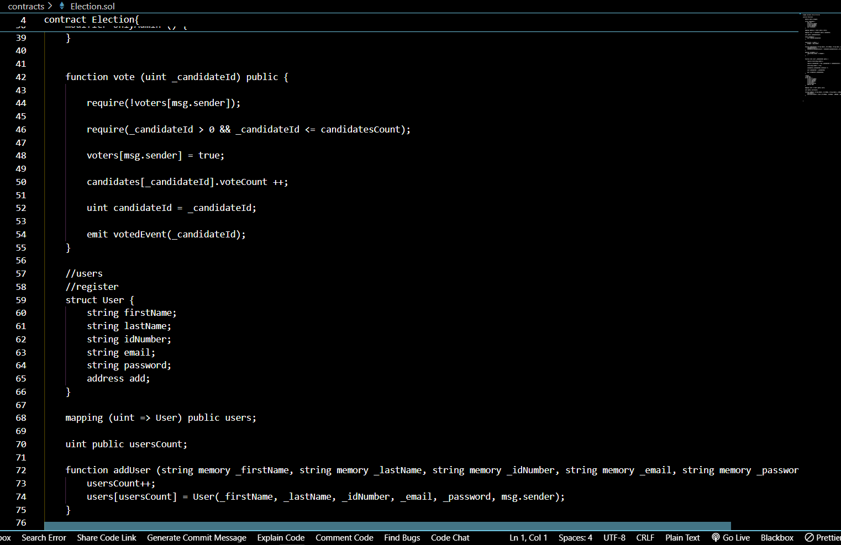

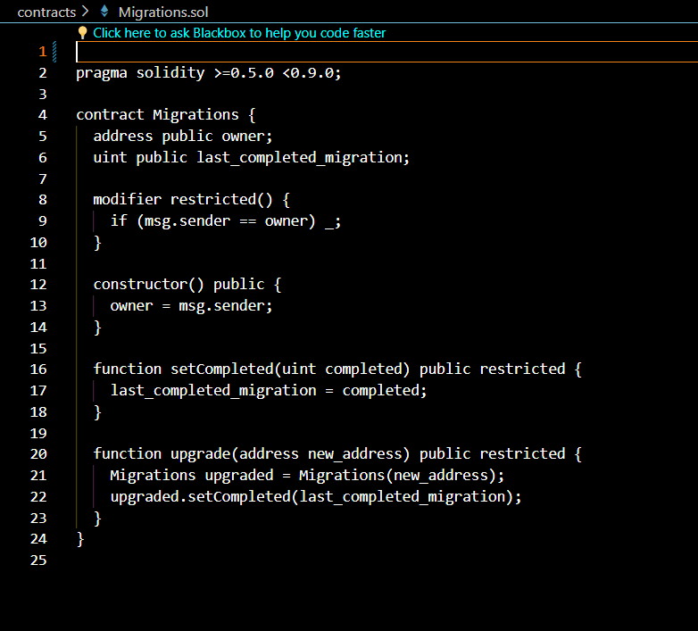

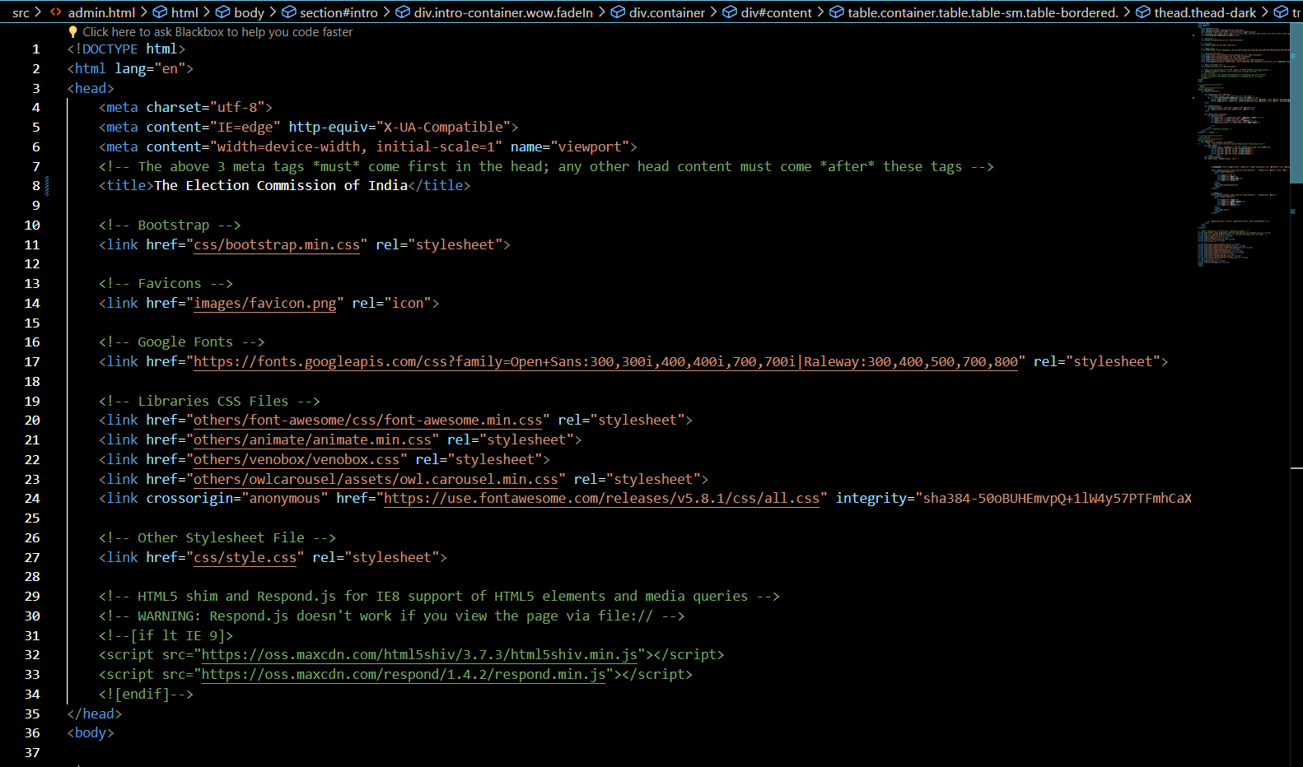

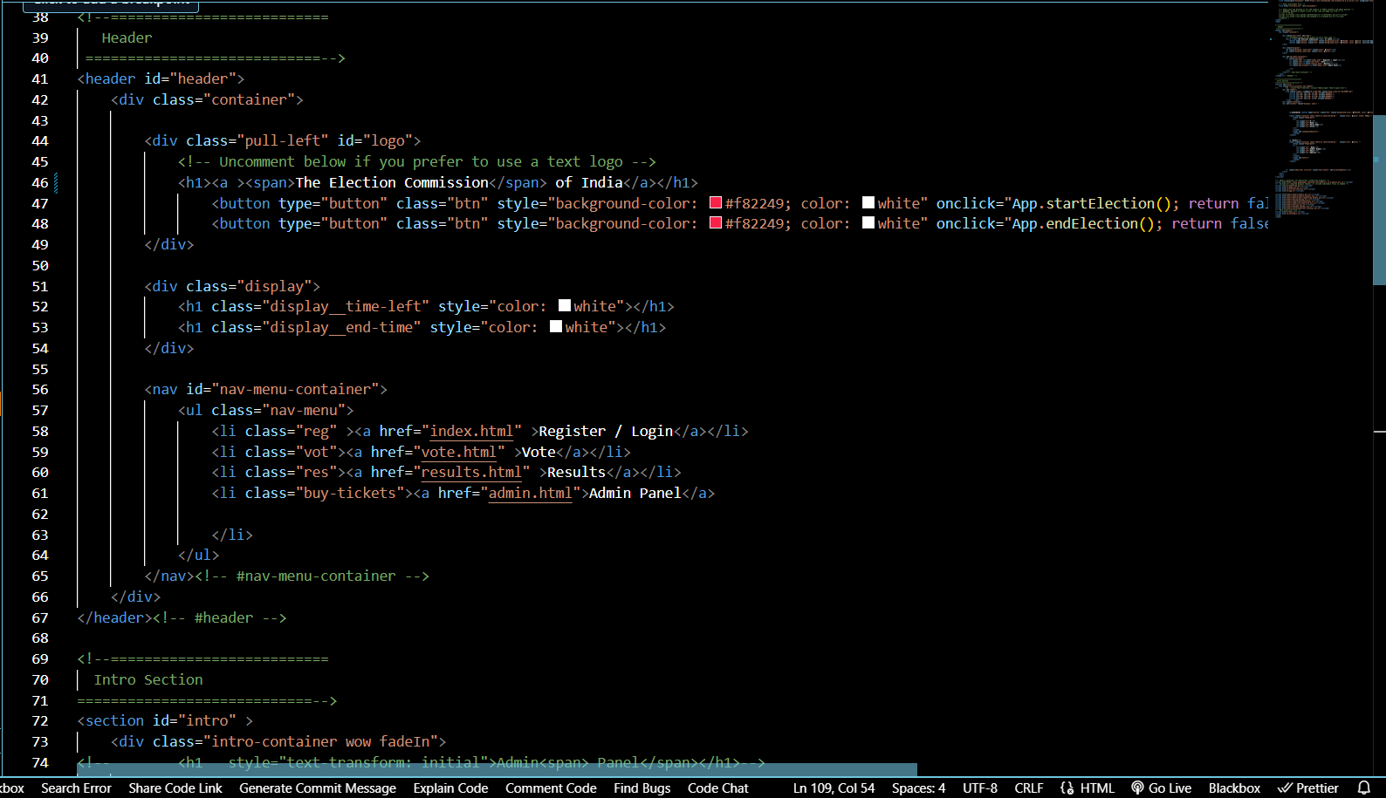

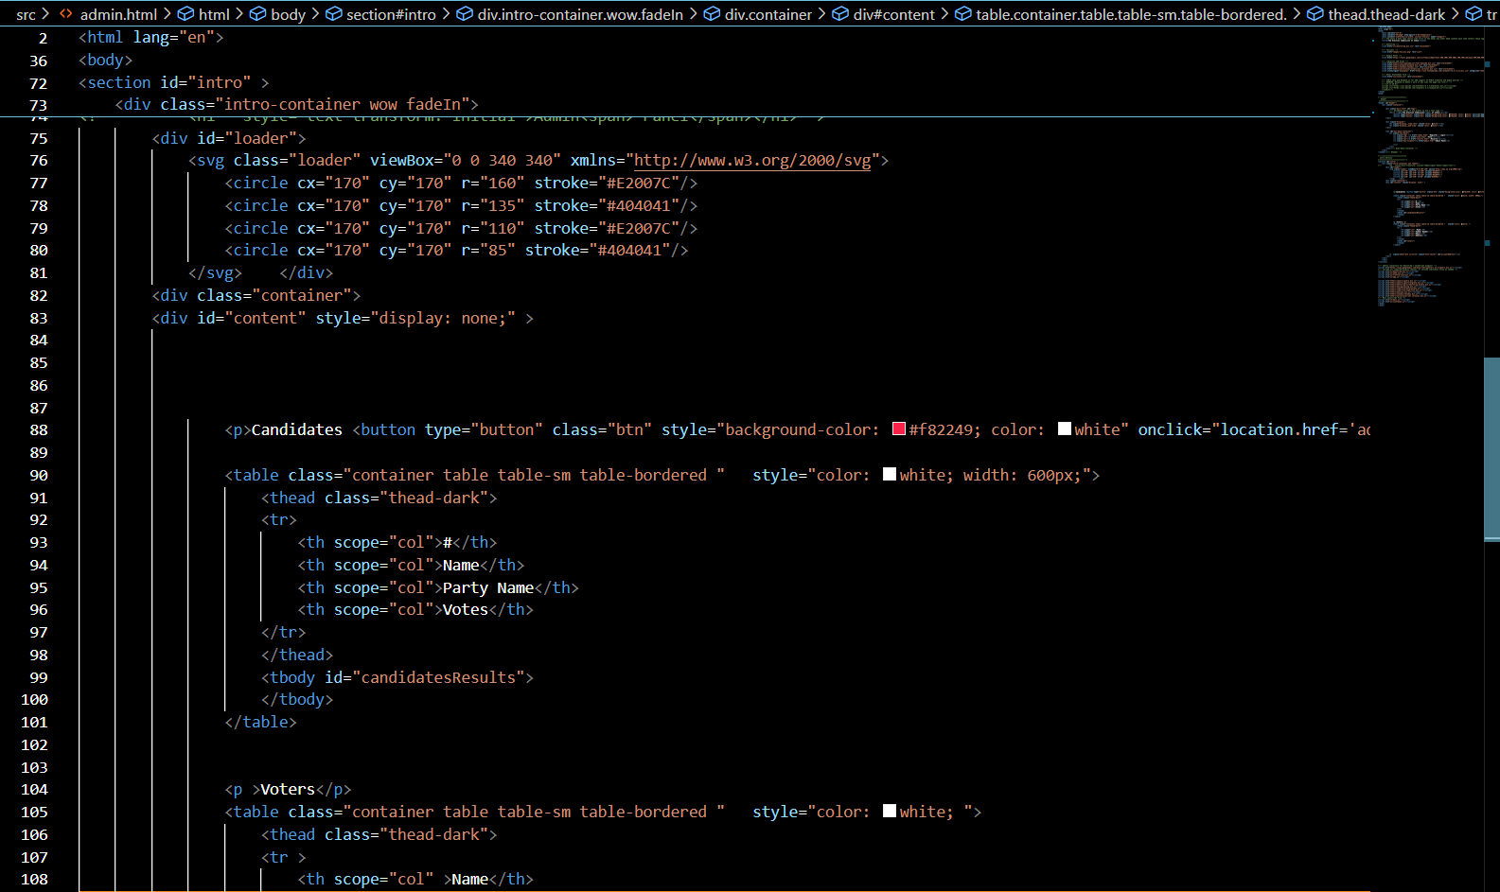

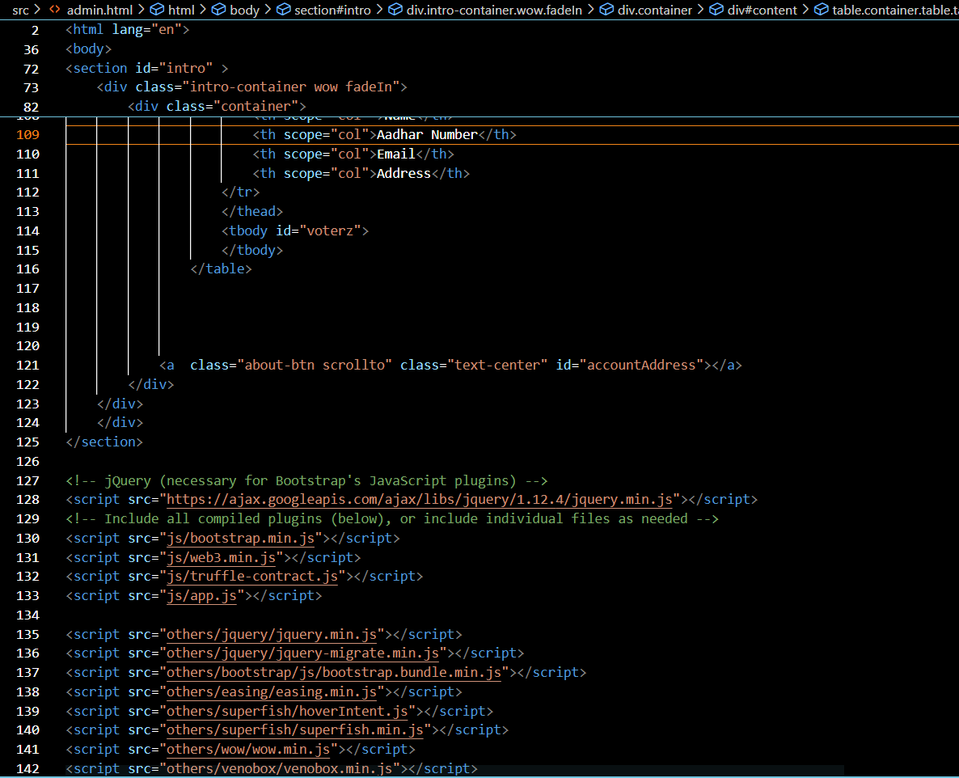

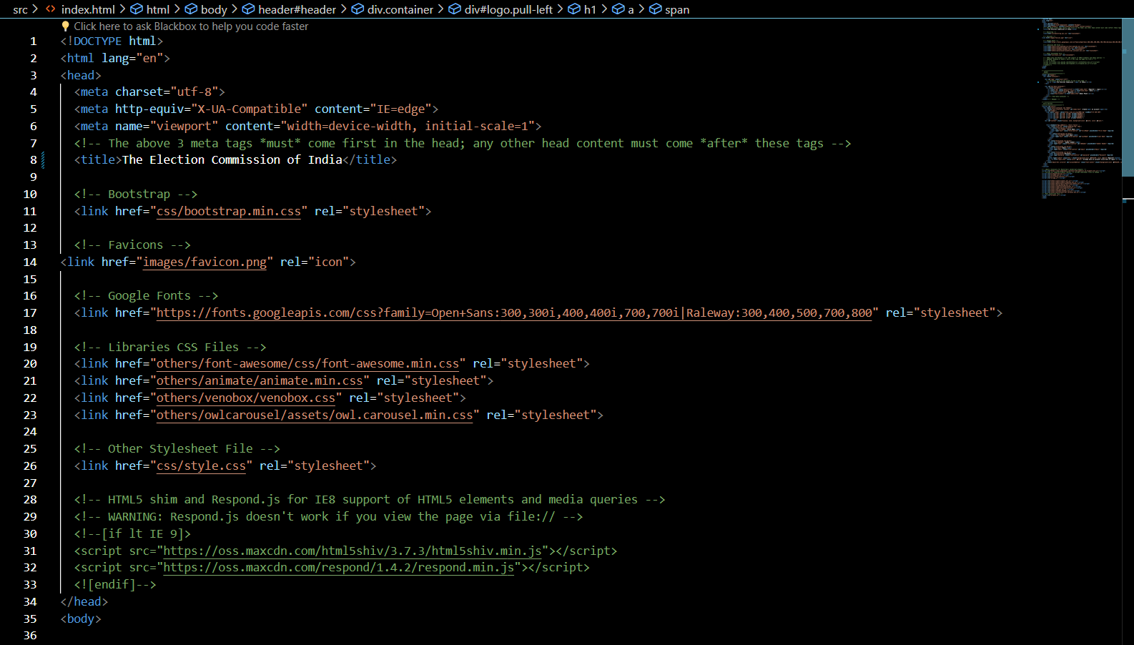

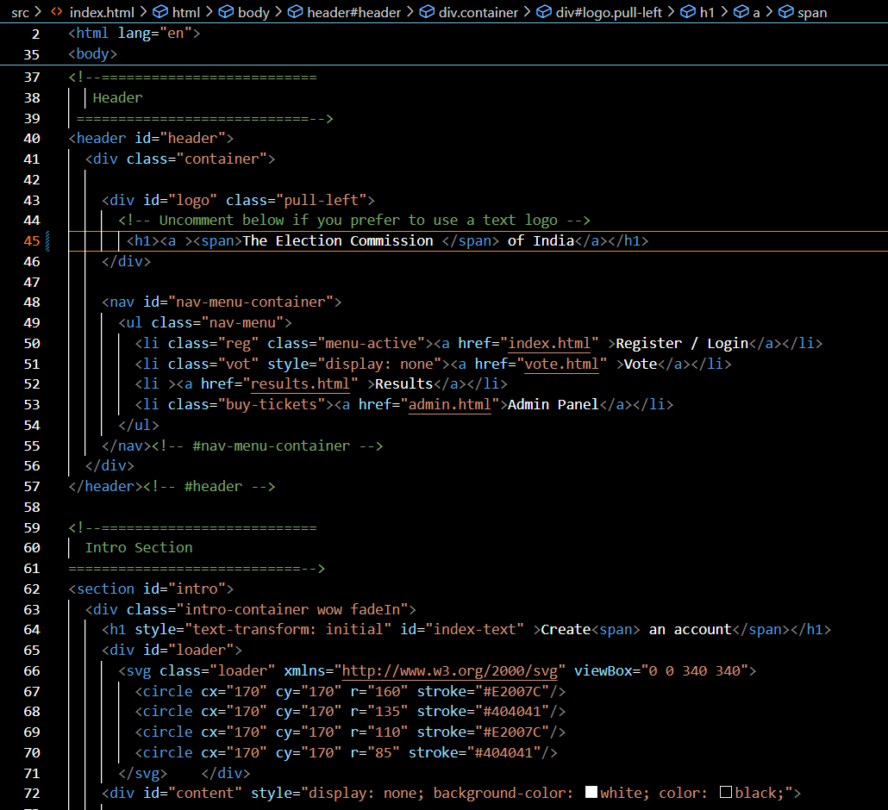

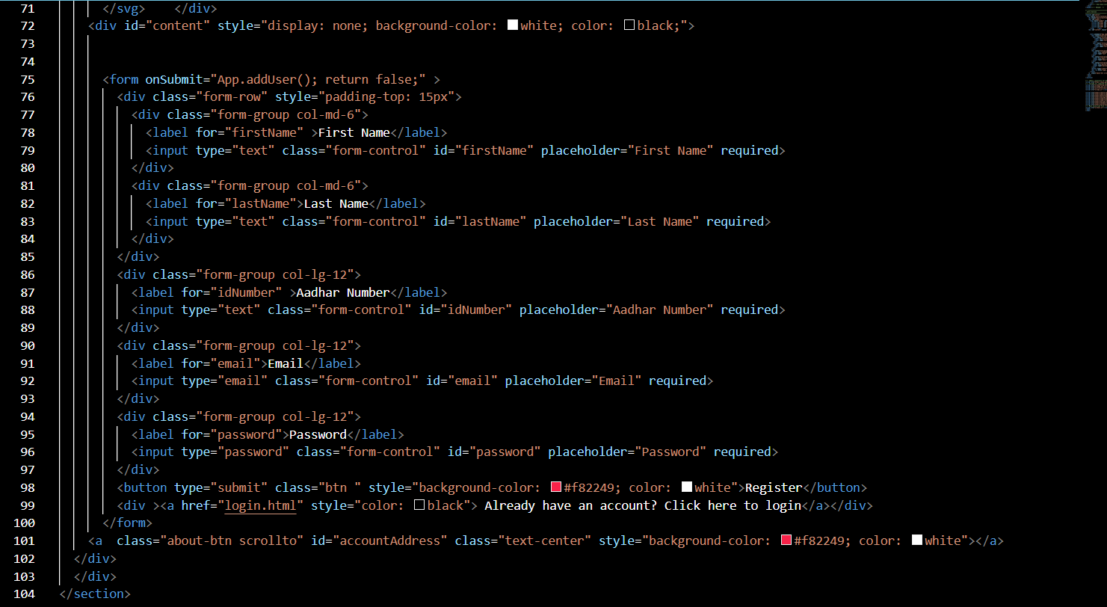

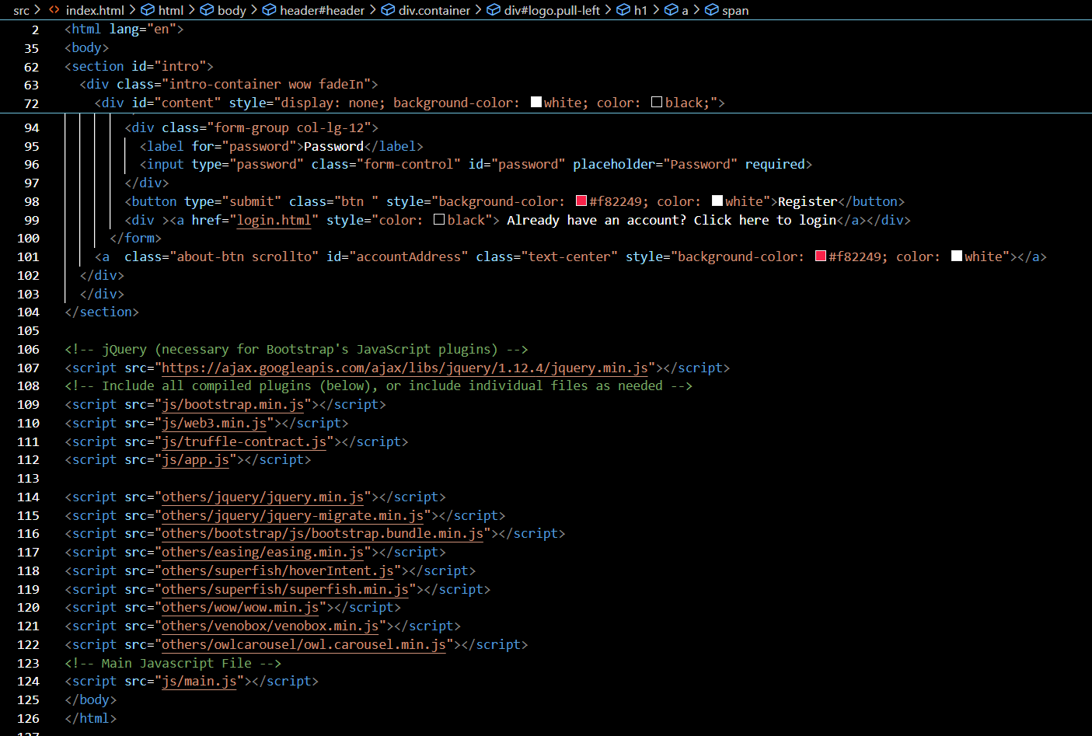

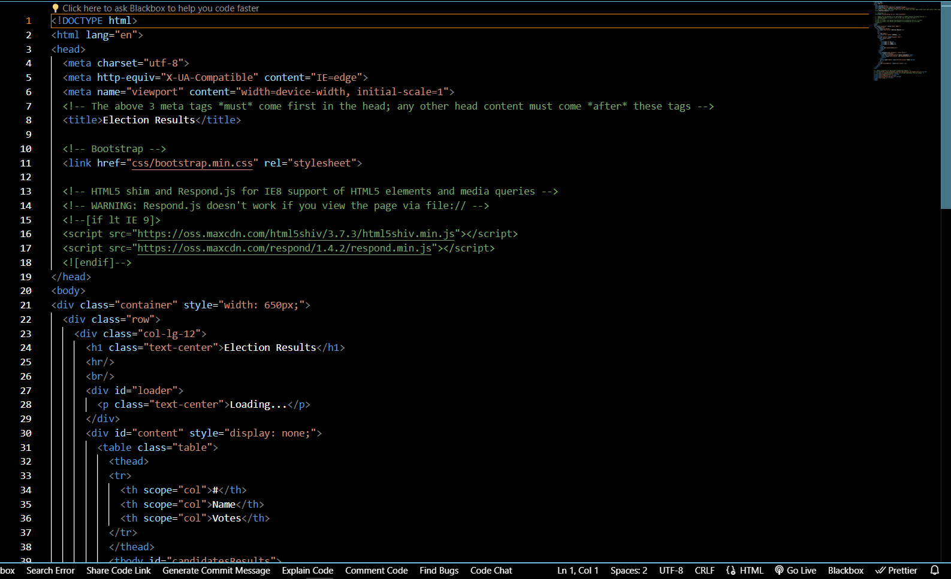

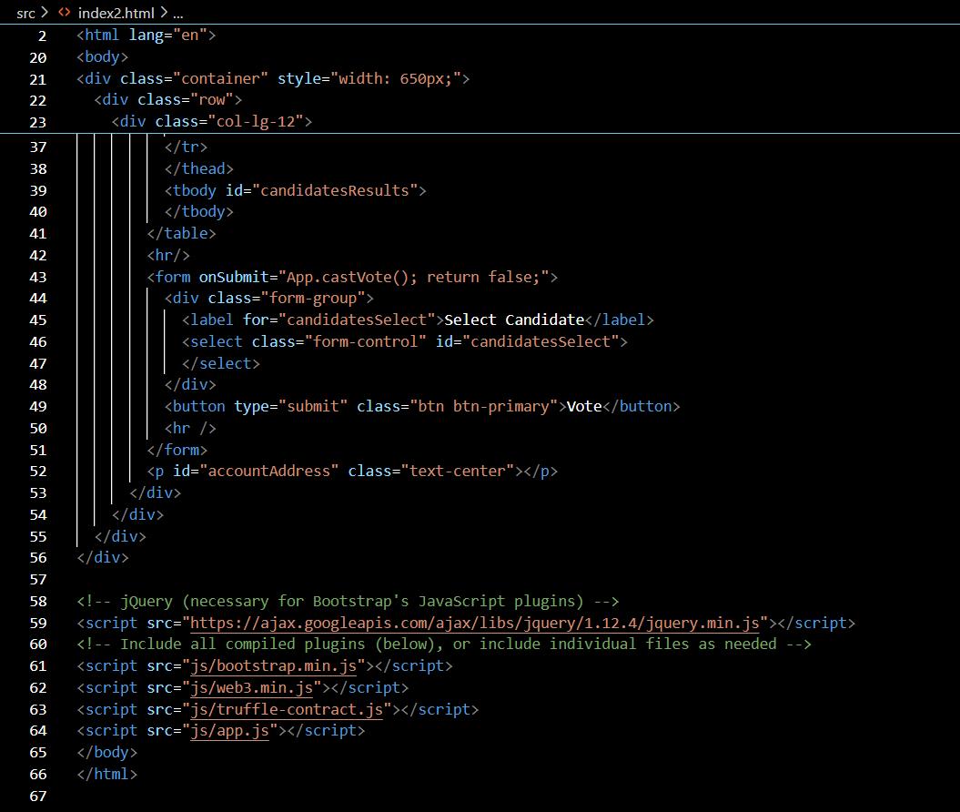

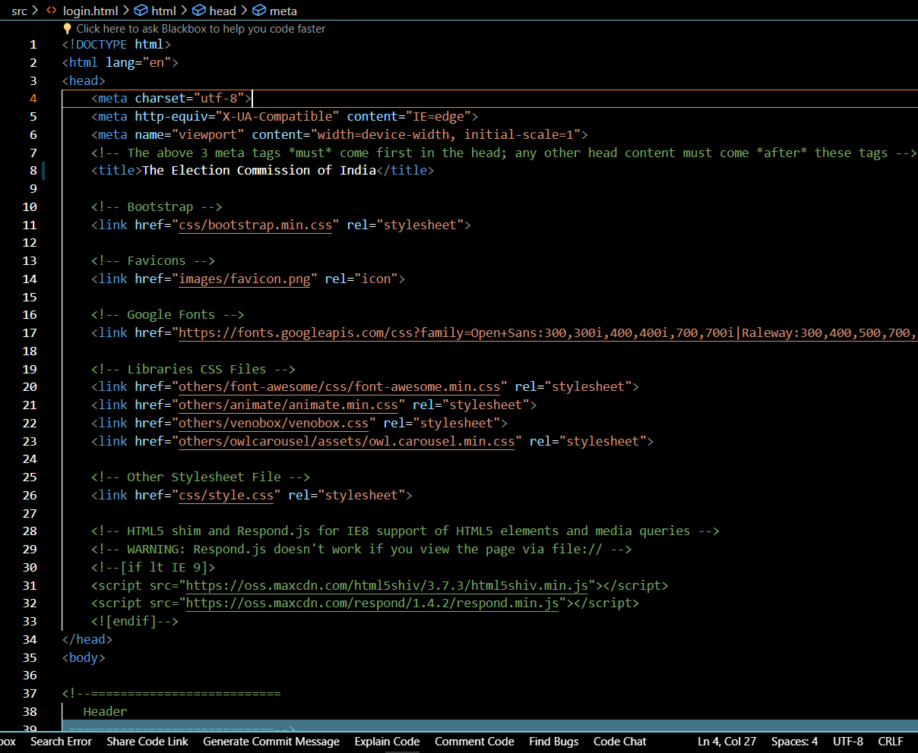

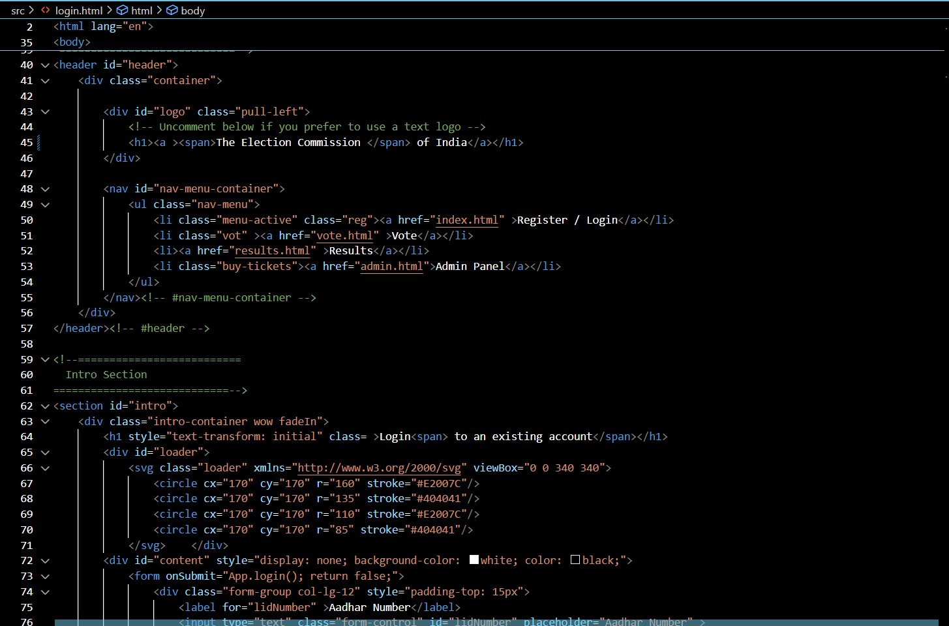

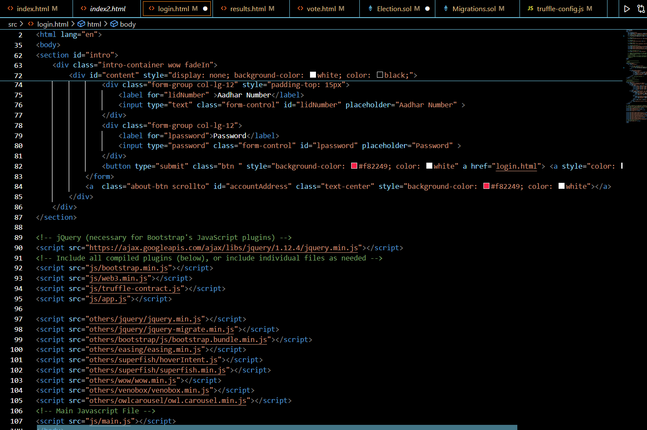

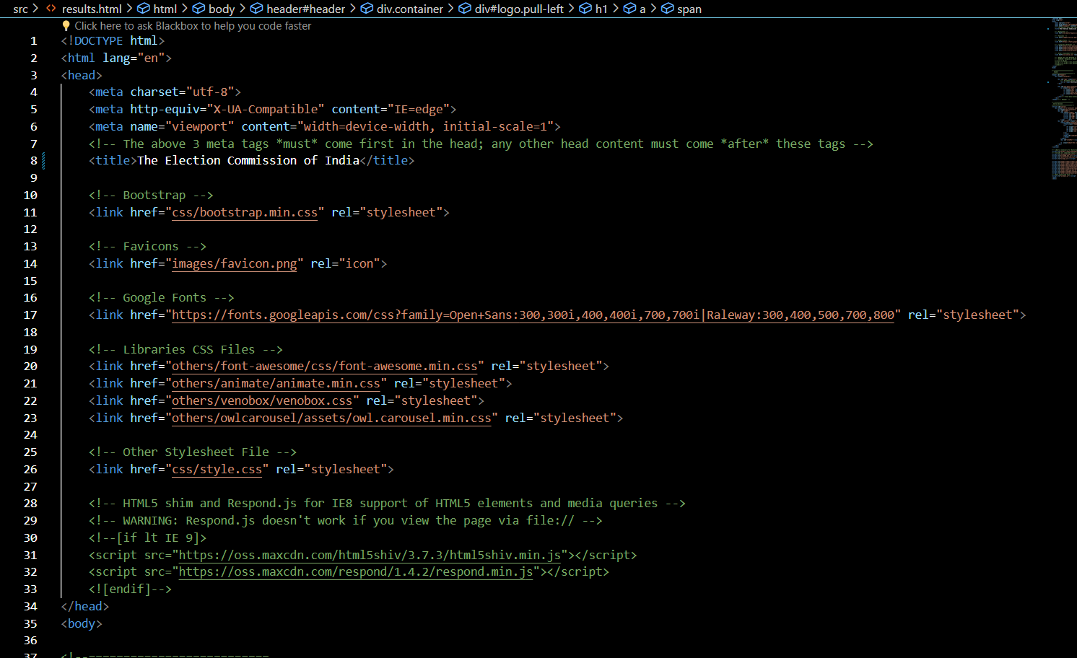

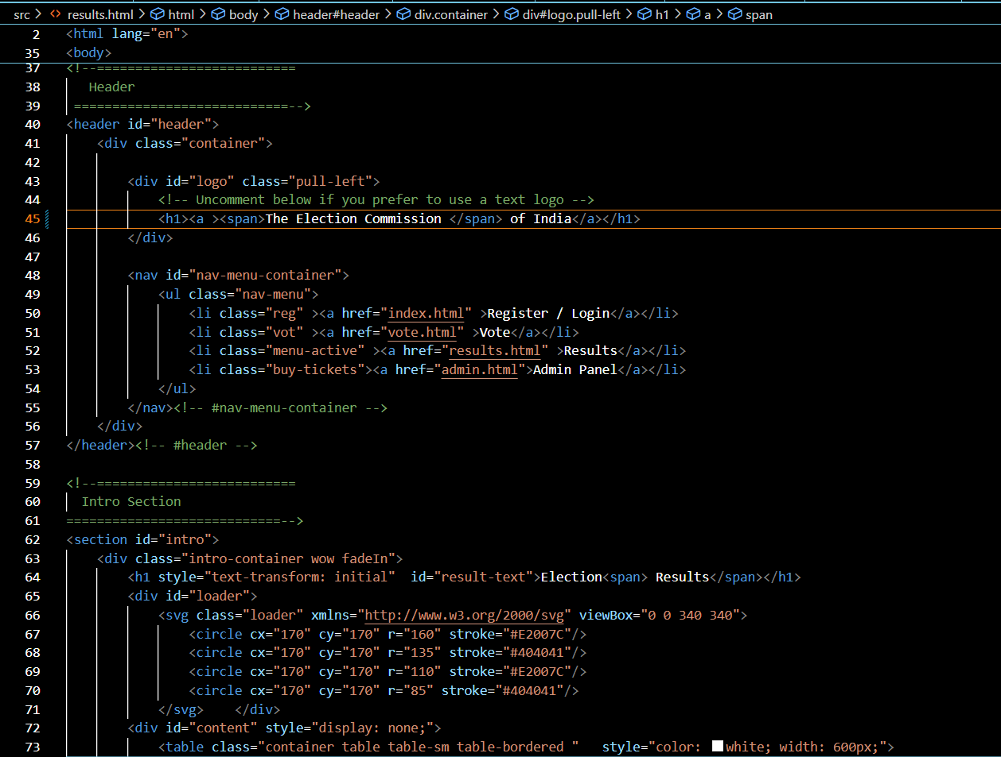

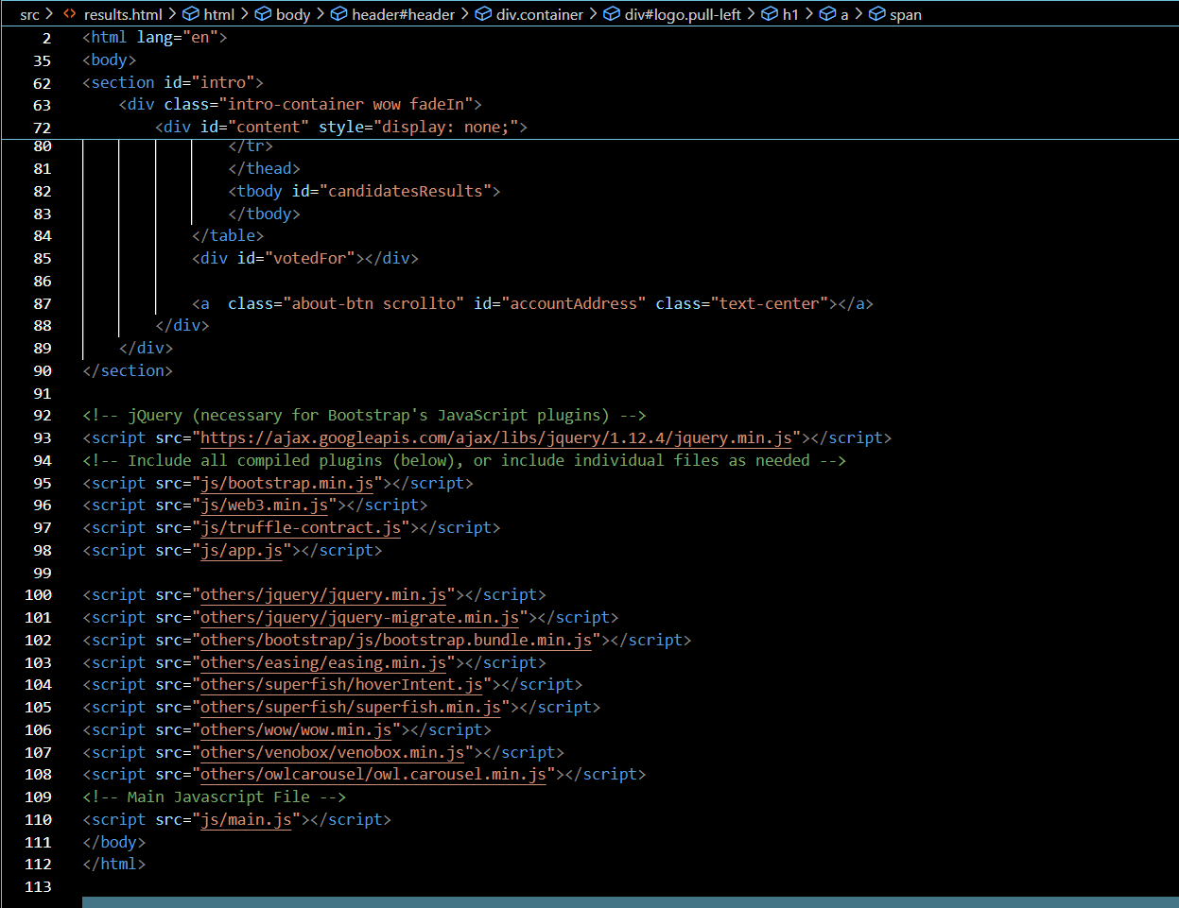

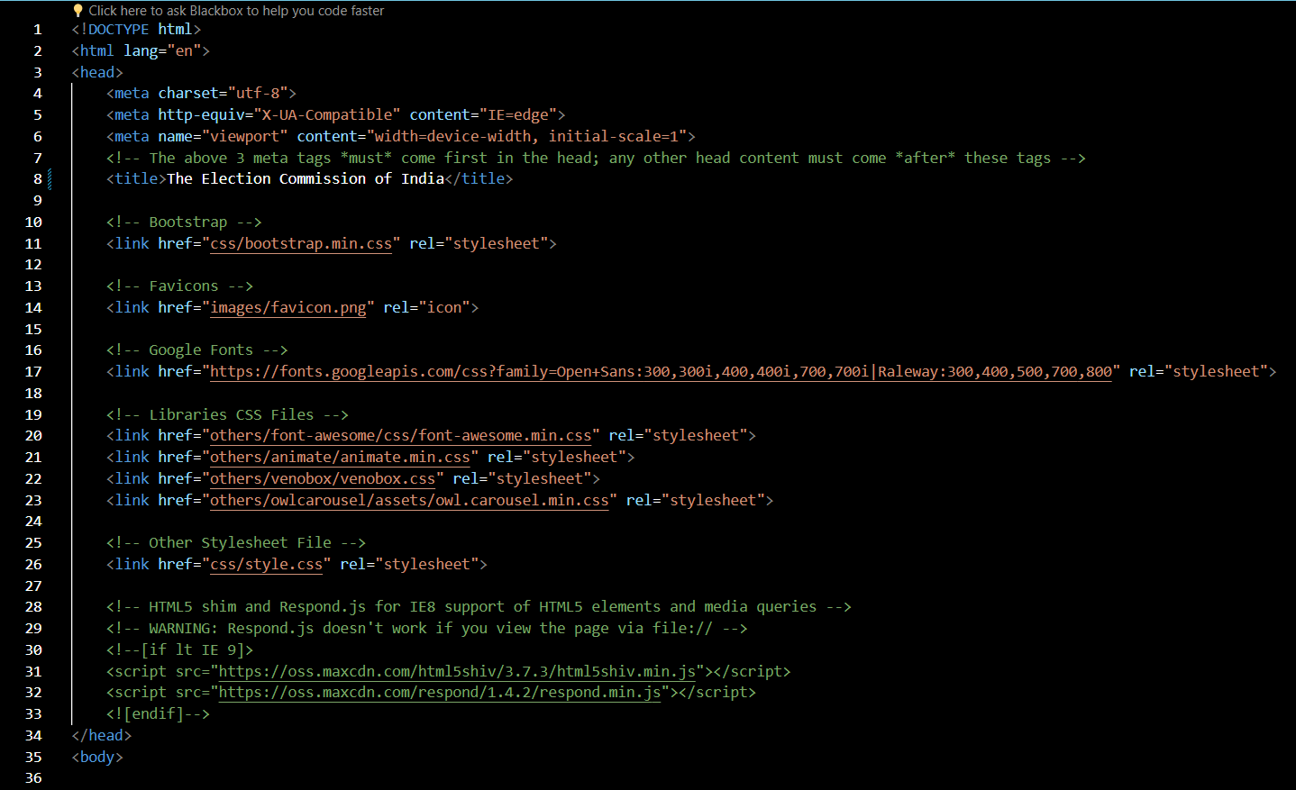

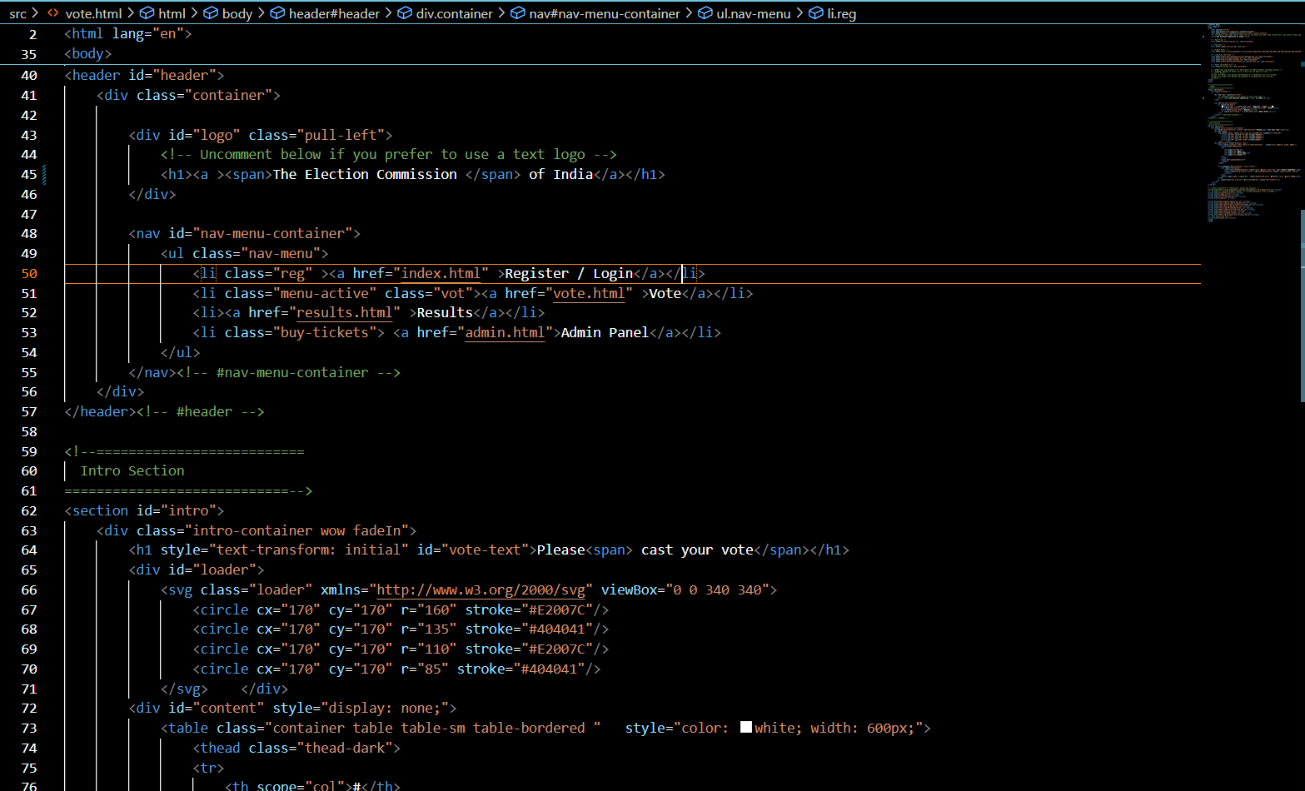

Fig 6.35

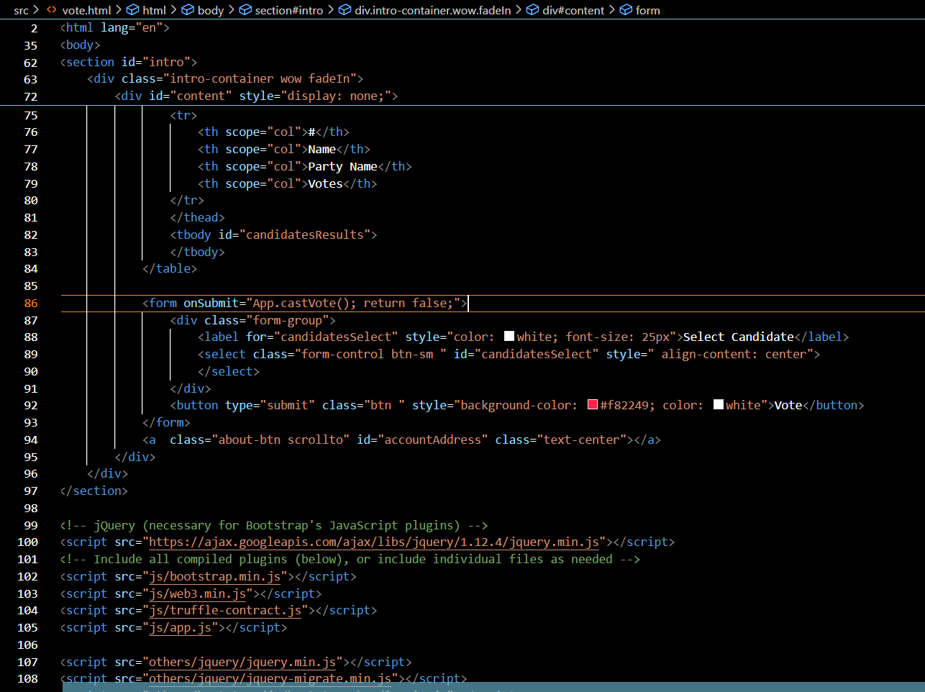

Fig 6.36

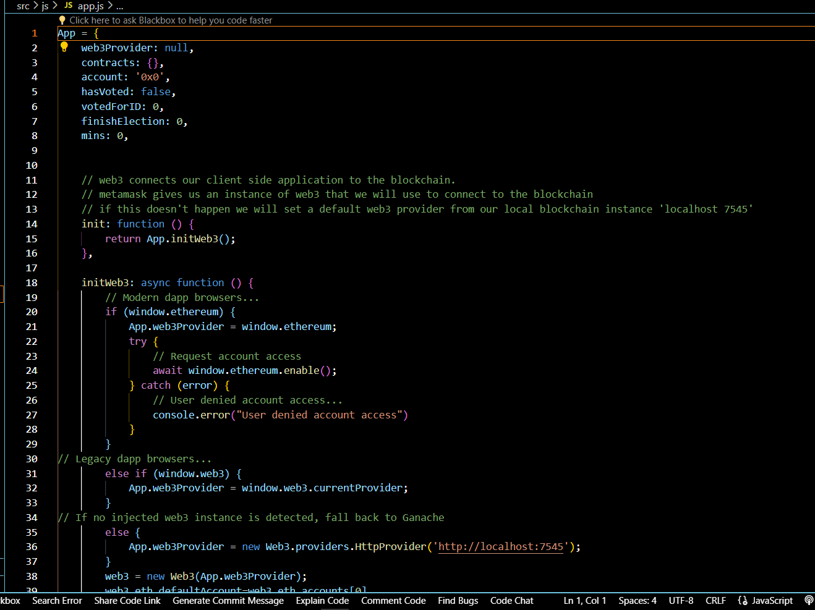

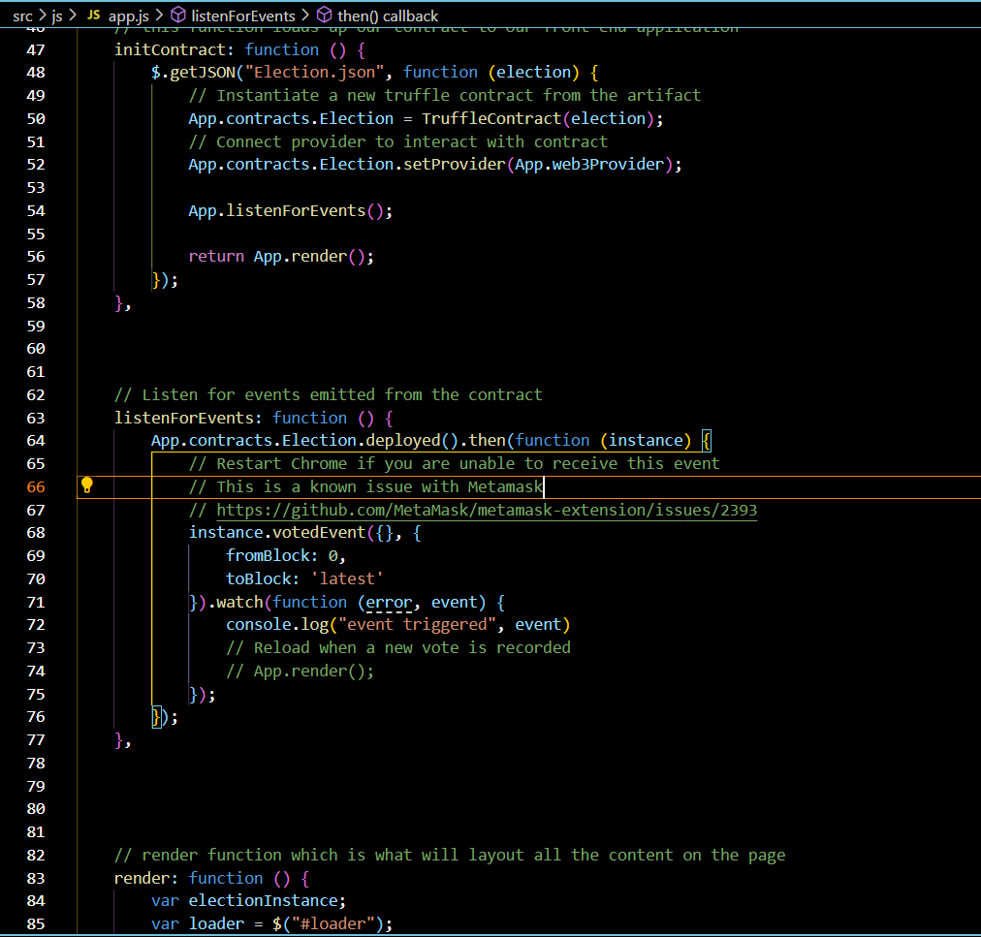

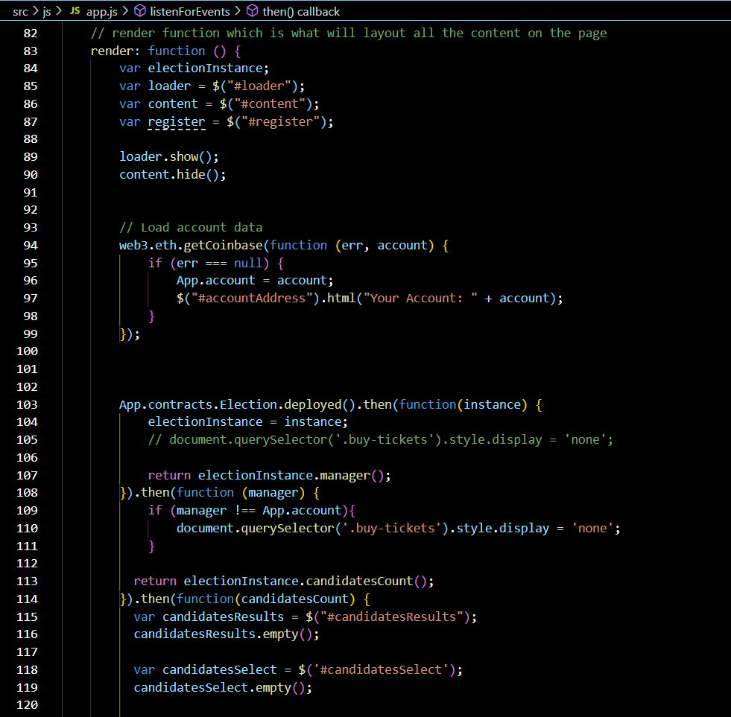

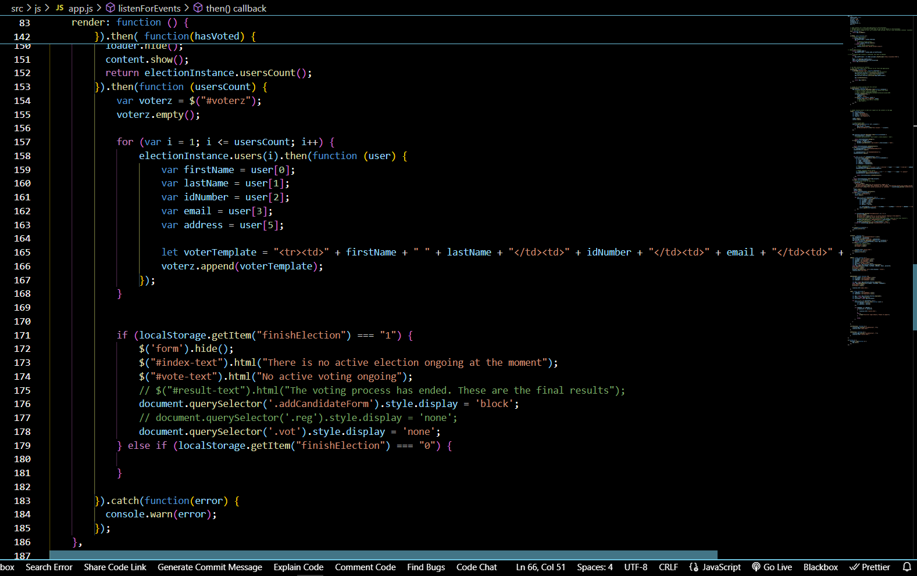

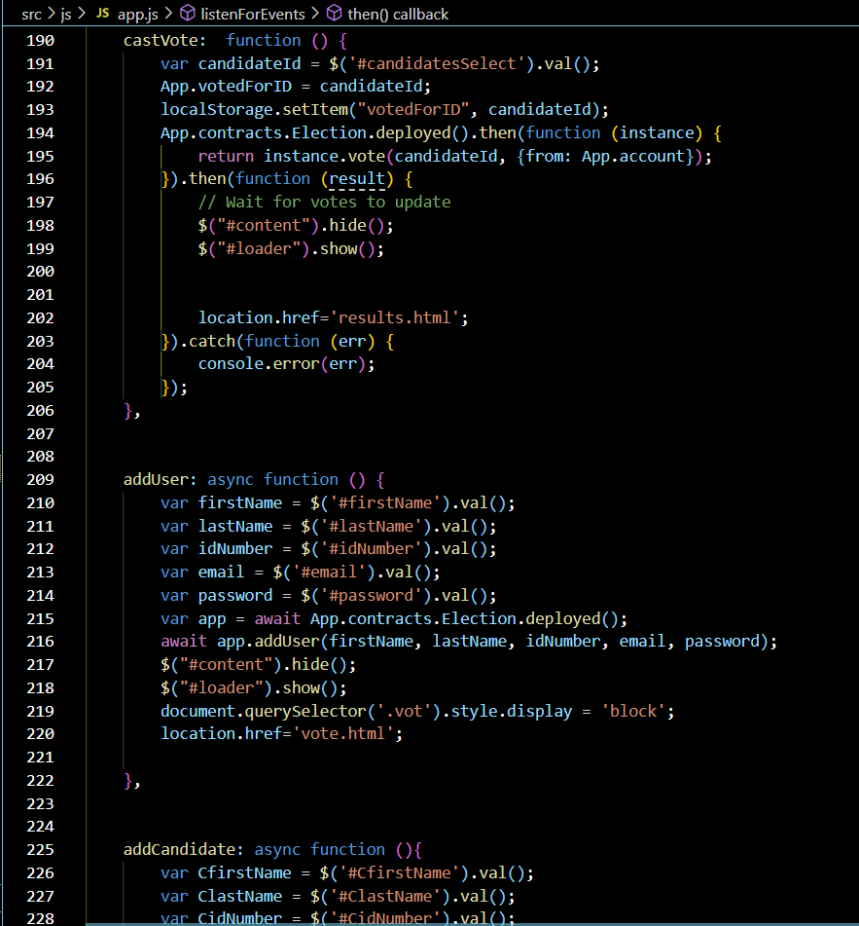

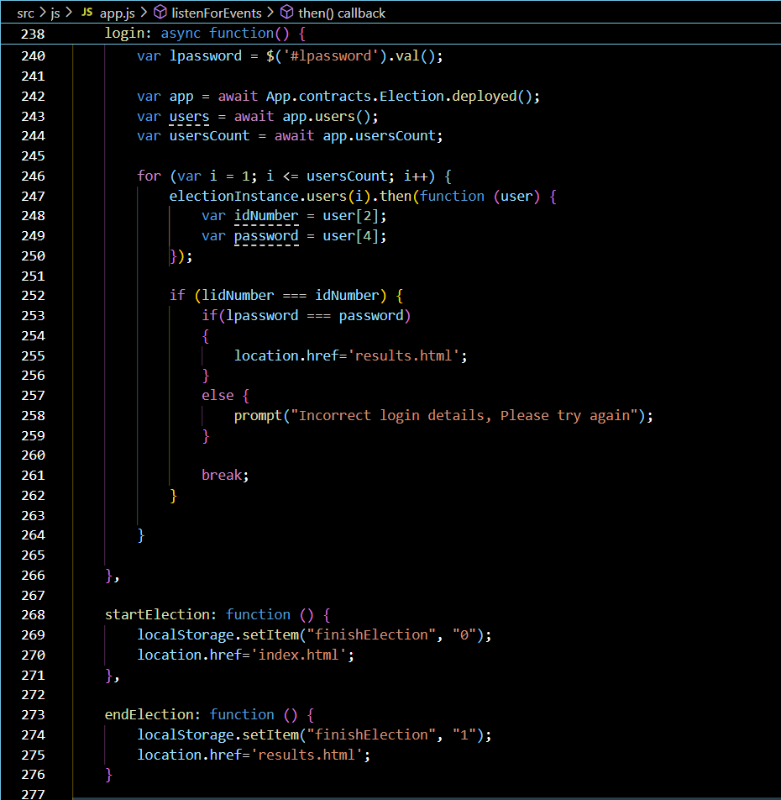

**7.CONCLUSION:**

The concept of incorporating online voting systems to make the public election process cheaper, quicker, and easier is a compelling one in modern society. We have deployed online-based blockchain voting framework in this project where smart contracts are used to allow secure and cost-effective election while preserving the secrecy of the voters. Compared with previous research, we have shown that the blockchain technology provides a new opportunity for democratic countries to move from the pen and paper elect scheme and paperless direct-recording electronic voting machine (DRE) to a more cost effective and time-efficient election scheme, thus mounting the security measures of the current scheme, and offering new accessibility.

**Reference**

* Adida B. and Rivest, R. L. (2006). Scratch & vote: Self-contained paper-based cryptographic voting, in Proceedings of the 5th ACM Workshop on Privacy in Electronic Society, ser. WPES '06. New York, NY, USA: ACM, 2006, pp. 29-40.
* Chaum, D., Essex, A., Carback, R., Clark, J., Popoveniuc, S., Sherman, A. and Vora, P. (2008) Scantegrity: End-to-end voter-variable optical- scan voting, IEEE Security Privacy, vol. 6, no. 3, pp. 40- 46, May 2008.
* Grønnevik, Ø., Martin, H., & Hoen, K. (2018). "Blockchain for Voting Systems:
* Benefits and Challenges." Proceedings of the IEEE International Conference on
* Blockchain (ICBC), pp. 377-382.
* Kshetri, N., & Voas, J. (2018). "Blockchain’s roles in strengthening
* cybersecurity and protecting privacy." IT Professional, 20(3), pp. 15-19.
* Swan, M., Chang, S., & Smith, J. (2017). "Blockchain: Blueprint for a New
* Economy." O'Reilly Media.
* Alvarez, R., Li, Y., & Sue, M. (2019). "Scaling Blockchain for Voting." IEEE
* Transactions on Dependable and Secure Computing, 16(5), pp. 775-787.
* W3Schools. (n.d.). "HTML, CSS, JavaScript Tutorials." Retrieved from
* <https://www.w3schools.com/>
* MySQL Documentation. (n.d.). "MySQL Database Server Documentation."
* Retrieved from <https://dev.mysql.com/doc/>
* Hyperledger. (n.d.). "Hyperledger Frameworks and Tools for Building
* Blockchain Solutions." Retrieved from <https://www.hyperledger.org/>

­­­­